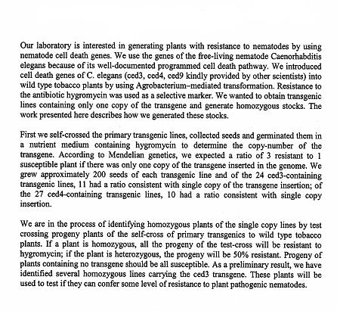
Example 1: Genetic Experiments on Transgenic Tobacco Plants Expressing Nematode Cell Death Genes

Example 2: 19th Century Luddism and its Modern Equivalents


