Report on Graduate Core Competency
Discipline-Specific Methodology

Graduate Core Competency Assessment, AY 2024-25

Reported by Director of Assessment, Dr. Douglas Fraleigh,
and Graduate Core Competency Chair, Dr. Frederick Peinado Nelson
CALIFORNIA STATE UNIVERSITY, FRESNO
August 2025

Report on the Assessment of
Graduate Programs Discipline-Specific Methodology
California State University, Fresno
August 12, 2025

EXECUTIVE SUMMARY

Background
Fresno State developed its graduate core competency assessment process, based on the 2013 Handbook of Accreditation. WSCUC Standard of Accreditation 4.1 required that “the institution employs a deliberate set of quality-assurance processes in both academic and non-academic areas, including … assessment of student learning.” At the undergraduate level, WSCUC Criteria for Review 2.2a required that “programs ensure the development of core competencies including, but not limited to, written and oral communication, quantitative reasoning, information literacy, and critical thinking.” At the graduate level, the WSCUC 2013 Handbook of Accreditation provided that “graduate programs and graduate-only institutions are expected to define and assess the generic intellectual competencies that are foundational in their field. WSCUC Criteria for Review 2.2b provided that programs must “establish clearly stated objectives differentiated from and more advanced than undergraduate programs in terms ... student learning outcomes.”
The 2023 Handbook of Accreditation also references core competencies. CFR 2.2 requires that “degree programs engage students in an integrated course of study of sufficient breadth and depth. These programs ensure the development of core and professional competencies relevant to the level of the degree.”
At a graduate faculty meeting in Fall of 2016, University Director of Assessment, Dr. Melissa Jordine, discussed this issue thoroughly with the faculty who attended. A majority of those faculty agreed to provide feedback on potential graduate core competencies to be assessed University-wide. A Qualtrics survey based upon this discussion was created and sent to all faculty members, including those who had not attended the graduate meeting. The responses indicated a clear consensus of opinion. Nearly all respondents, with two exceptions, recommended adopting three core competencies--written communication, advanced disciplinary knowledge or skill, and research/discipline-specific methodology.
At a March 4, 2020 Graduate Coordinators’ meeting, a plan for graduate core competency assessment was established. The plan included a rotation through three graduate core competencies 1) Advanced Disciplinary Knowledge/Skill, 2) Research Method (Discipline-Specific Methodology), and 3) Written Communication. In 2019, a pilot assessment of written communication was conducted and feedback was attained to ensure the graduate core competencies captured a wide spread of disciplines and their culminating exercises across the university. In 2020, Advanced Knowledge/Skill graduate core competency was implemented and findings were shared in a report dated August 9, 2021. In 2021-2022, Discipline-Specific Methodology graduate core competency assessment was implemented and findings were shared in a report dated July 1, 2022. In 2022-2023, the core competency Written Communication assessment was implemented and shared in a report dated July 1, 2023. Each of the three graduate core competencies is assessed on a rotating basis, as shown in Figure 1.
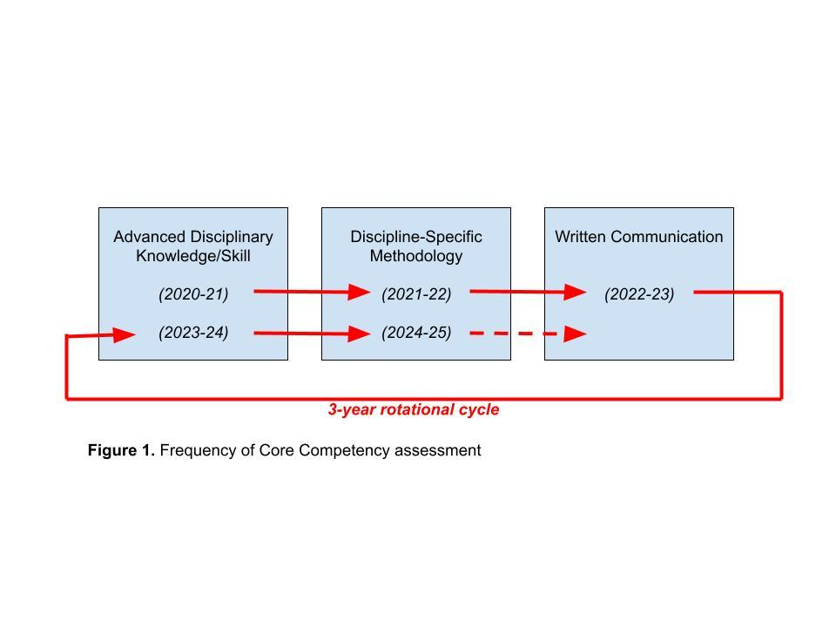
Specifically, in each rotation cycle:
- Graduate students’ culminating experiences will be evaluated for the corresponding core competency being assessed.
- If a graduate program had less than ten students graduate in a given year (summer, fall, and spring), then all culminating experiences will be assessed. If a program has ten or more students graduate, then ten culminating experiences will be randomly selected for assessment.
- A common rubric will be utilized for each core competency and used to assess students’ performance. Each graduate core competency rubric was developed based on graduate coordinators’ feedback and finalized by the university assessment coordinator subcommittee.
- A reporting form will be provided to each graduate coordinator. After faculty score the students’ work and provide comments, the form will be returned to the Core Competency Assessment Chair and University Director of Assessment.
Graduate Programs Discipline-Specific Methodology Evaluation Process
For AY 2024-25, Discipline-Specific Methodology was assessed. The assessment was overseen by the Director of Assessment, Dr. Douglas Fraleigh, and chaired by the Graduate Core Competency Chair, Dr. Frederick Peinado Nelson. Students’ culminating experiences were assessed using a rubric developed collectively by the graduate coordinators (see Appendix A).
Students were assessed on three criteria, demonstration of discipline-specific methodology:
- Criteria 1. Appropriate discipline-specific methodology selection for scholarship.
- Criteria 2. Appropriate application of the discipline-specific methodology in the student’s scholarly or creative work.
- Criteria 3. Appropriate reflection, analysis, and/or interpretation on the application of the discipline-specific methodology.
Students received a score of 3 (advanced proficiency), 2 (proficiency), or 1 (partial proficiency) on each criterion. The benchmark was that 90% of students would receive a score of 2 (proficiency) or higher on all three criteria.
Graduate coordinators were provided a variety of professional learning opportunities throughout the 2024-2025 academic year to ensure they understood the process for implementing the graduate core competency evaluation. Dr. Fraleigh and Dr. Nelson presented the information at a university level graduate coordinator meeting during the spring of the academic year. During these sessions, the why, what and how of the graduate core competency evaluation implementation was covered. In addition, reminder emails with specific instructions and opportunities for additional support were provided each semester to all graduate program coordinators. Dr. Nelson established a spreadsheet for tracking submission of reports from coordinators. One on one coaching opportunities were also provided to graduate coordinators who requested one one one support throughout the academic school year. Additional outreach was provided to newly appointed coordinators who were not familiar with the Graduate Core Competency assessment process.
Results of the Graduate Programs Discipline-Specific Methodology Evaluation
Table 1 shows the graduate core competency Discipline-Specific Methodology Evaluation submissions and results at Fresno State for academic year 2024-25. The benchmark was that 90% of students would receive a score of 2 (proficiency) or higher on all three criteria. The sample size of N=406 submissions was representative of rubric submissions from 51 graduate programs across the university. This sample size represents a substantial increase in participation from the previous year’s assessment (2021-22), which evaluated 267 submissions from 32 graduate programs. Programs from each of the university’s eight colleges participated in the assessments. The results were as follows:
- Criteria 1 Proficiency (2 or above): 393, 97% of the submissions, earned a rating of 2 or higher.
- Criteria 2 Proficiency (2 or above): 390, 96% of the submissions, earned a rating of 2 or higher.
- Criteria 3 Proficiency (2 or above): 387, 95% of the submissions, earned a rating of 2 or higher.
- Overall Proficiency of (2 or above) for all Criteria: 377, 93% of the submissions earned of a rating of 2 or better on all three criteria.

Based on the 90% benchmark, expectations were met for student proficiency in the Discipline-Specific Methodology Core Competency.

Table 1. Proficiency Scores Main Sample (N=406) (sample size is representative of submissions from 51 graduate programs)
Sample |  | Criteria 1 Proficiency  (2 or above) | Criteria 2 Proficiency (2 or above) | Criteria 3 Proficiency  (2 or above) | Overall Proficiency Criteria 1-3  (2 or above on all three criteria)
All Submissions  Projects (205)  Thesis (87)  Comprehensive Exams (105)  E-Portfolio (9) | N = 406 | 393 | 390 | 387 | 377
Proficiency Benchmark is 90% or higher |  | 97% | 96% | 95% | 93%

It is important to note that 377 of the 406 submissions met the benchmark of proficiency in each of the three criteria. A total of 29 out of 406 submissions evaluated did not achieve proficiency in all three criteria. Criteria 3, assessing proficiency in reflection, analysis, and/or interpretation of the discipline-specific methodology, was the lowest scoring criterion, although at a 95% level of achievement of all submissions evaluated. This repeats the data from the 2021-22 academic year assessment of discipline-specific methodology, where Criterion 3 was the lowest of the criteria evaluated, with 96% of submissions evaluated proficient. This data suggests the opportunity for additional learning experiences that emphasize the relevance of meaningful reflection, analysis, and interpretation of the application of discipline-specific methodology.
Table 2 shows themes from analysis of the program coordinator comments on individual student performance of the discipline-specific methodology graduate core competency assessment. Table 3 highlights themes from program coordinator comments on the overall performance of their programs, relevant to the Discipline-Specific Methodology Graduate Core Competency. Representative comments are provided as exemplars for each theme.
Table 2. Themes from Faculty Comments on Individual Student Performance
Themes | Representative Comments
Strengths
Selecting and applying appropriate methodologies | "Discipline specific methodology was strong”  "Excellent interpretive application of rhetorical criticism methodology"
Clear and appropriate design | methods "appropriate to their object of study”
Proficiency with tools and principles | Effective use of tools and theories: post-colonial theory, trauma theory  Use of SPSS
Professional and publishable work | “Award-winning”  “Great potential for publication”
Real-world application | “Resource guide for juvenile youth”  Addresses a "societal need”
Innovative and creative approaches | Taking “a chance on using social media for education”  Creating "powerful visuals”
Challenges
Analysis, interpretation, and reflection | “Superficial” or “limited” analysis  Need to “delve deeper”
Connecting findings to broader contexts | “Link qualitative and quantitative results clearly”  “Present concepts in a clear manner to the general audience”
Writing and clarity | “Some writing clarity issues”  “Need to provide additional resources”  “Need a more robust literature review”

Table 3. Themes from Faculty Comments on Overall Program Performance
Themes | Representative Comments
Strengths
Command of discipline-specific methodology | "Students excelled at analysis based on application of the discipline-specific methodology"  "All five theses display advanced proficiency in the selection of discipline-specific methodology"  "100% at proficient level and 73% at Advanced Proficiency level”
Application of knowledge | "linking epidemiological data to health policy"  "applying theory to practice in meaningful and context-rich ways.”
High quality and effort | "outstanding"  “very strong"  "MFA and/or professional quality"  "uniformly outstanding"
Effective use of tools and methods | "strong use of discipline-specific methods (e.g., market research, regression analysis, internal audits)"  "several VLSI simulation or design tools"
Challenges
Writing and communication skills | "writing is not up to snuff many times"  "struggle to convey their points/arguments clearly in writing"  “need for a more formal and technical writing style’
Analysis, interpretation, and reflection | “More thorough analysis and interpretation needed"  [some students] "find it difficult to extract insights from data and interpret their findings through the lens of existing literature"
Connecting to broader literature | “often struggle to effectively link their research findings back to the existing body of knowledge in their field”  "they struggled to connect their findings back to the literature...how they are contributing to our collective understanding of the topic"
Theoretical and methodological justification | Need for more robust discussions of “how methodological choices...may have impacted their results"  Need for students to provide a stronger "justification for the chosen methodology"

Feedback from program coordinators who completed the graduate core competency highlighted several potential areas for attention:
- Need for early intervention–weaknesses in writing and research skills could be addressed earlier in the curriculum, such as the development of research topics and questions.
- Support for research and writing–students need support in key areas, such as the literature review process.
- Use of artificial intelligence–the use of AI in projects and theses suggests programs should engage in discussions about the appropriate use of these tools.
Conclusions and Recommendations
Based on the benchmark established for proficiency, expectations were met for graduate student proficiency in the Discipline-Specific Methodology Core Competency. Based on faculty comments strengths emerged in several areas:
- Selection, description, and application of methodology
- Methodological skills and principles
- Application of the knowledge constructed in student work
- Effort and quality of work produced
Some areas for improvement included:
- Deeper analysis and reflection
- Analysis of and connections to foundational and current literature in the field
- Graduate writing skills
Recommendations from this assessment include:
- Identification of early opportunities for engagement with the research process, including the development of problem statements and research questions.
- Development of effective and meaningful practices for review of the foundational and current literature in the field, including both theoretical and research literature.
- Learning experiences to engage in thoughtful reflection on the process and products of methodological decisions.
- Graduate level academic writing support (grammar, structure, APA or other professional writing modality support).

Appendix A
Research or Discipline Specific Methodology Rubric
There are three different rubrics and departments will choose the one that best aligns with the culminating project they are evaluating. However, as a general rule: reviewers in non-performing arts disciplines will use the first rubric, reviewers in the visual and performing arts will use the second rubric, and reviewers evaluating non-research oriented exams or projects should use the third rubric.

Methodology Rubric for Theses, Projects, and other Research-Oriented Projects
Criteria | Advanced Proficiency (3) | Proficiency  (2) | Partial Proficiency (1)
Appropriate discipline-specific methodology selection for scholarship (i.e., project, thesis, portfolio, project report, comprehensive exam, program culminating assignment etc.) | Discipline-specific methodology selection is very clearly defined and described | Discipline-specific methodology selection is clearly described | Discipline-specific methodology selection is not clearly defined or described
Appropriate application of the discipline-specific methodology in the student’s scholarly or creative work | Application of the discipline-specific methodology is very well-aligned and described | Application of the discipline-specific methodology is clearly described | Application of the discipline-specific methodology is not well-aligned and described
Appropriate reflection, analysis, and/or interpretation on the application of the discipline-specific methodology | Excellent reflection, analysis, and/or interpretation for use of discipline-specific methodology and outcome | Reflection, analysis, and/or interpretation for use of discipline-specific methodology and outcome is evident | Reflection, analysis, and/or interpretation for use of discipline-specific methodology and outcome is not evident

Methodology Rubric for Exams or Non-Research Oriented Projects

Criteria | Advanced Proficiency (3) | Proficiency (2) | Partial Proficiency (1)
Discussion of Methodology OR Literature Review | Problem or question is very clearly described and a literature review OR discussion of views/sources is provided | Problem or question is clearly described and an adequate literature review OR discussion of views/sources is provided | Problem or question is not clearly described or no literature review OR discussion of views/sources is provided
Analysis of Research Methods | Sophisticated analysis of research methods used by sources | Analysis of research methods used by sources | Very little or no analysis of research methods used by sources
Analysis of Data | Sophisticated analysis of data or evidence | Analysis of data or evidence | Very little or no analysis of data or evidence

Methodology Rubric for Visual and Performing Arts Departments/Programs

Criteria | Advanced Proficiency (3) | Proficiency (2) | Partial Proficiency (1)
Reflects appropriate practices and styles | Project reflects practices and styles appropriate for the artwork, performance, or written piece. | Project reflects practices and styles appropriate for the artwork, performance, or written piece. | Project does NOT reflect practices and styles appropriate for the artwork, performance, or written piece.
Specific Method/Style | Method is clearly identifiable, appropriate, and exceeds the minimum requirements for graduate projects. | Method is clearly identifiable and appropriate. | Method is NOT clearly identifiable or appropriate.
Analysis of Methods | Specific steps in the process are clearly defined and artwork or performance is analyzed and related to relevant works by student. | Specific steps in the process are clearly defined and artwork or performance is analyzed and related to relevant works by student. | Specific steps in the process are NOT clearly defined and artwork or performance is NOT analyzed or NOT related to relevant works by student.

