Quantitative Reasoning Assessment Report

California State University, Fresno

2022-2023

Reported by Quantitative Reasoning Core Competency Committee

**September 2023**

California State University, Fresno: Quantitative Assessment Report

This report on quantitative reasoning competency of undergraduate graduating seniors pursuing either a Bachelor of Art (BA) degree or a Bachelor of Science (BS) degree at California State University, Fresno, has been prepared by the Quantitative Reasoning Core Competency Committee (QRCCC).

Quantitative reasoning competency is one of the five core competencies identified by WASC Senior College and University Commission’s Standard. The quantitative reasoning competency assessed in AY2022-23 is one of five core competencies of a Comprehensive Core Competency Assessment Plan of the University; the others are, Information Literacy (evaluated in 2018-19), Written Communication (evaluated in 2019-2020), Critical Thinking (evaluated in 2020-21), and Oral Communication (evaluated in 2021-22).

**Procedure**

The assessment committee consists of Dr. Douglas Fraleigh, the Director of Assessment, and Prof. Matthew Hopson-Walker and Dr. Serhat Asci, the College Assessment Coordinators for Arts & Humanities and for Agricultural Sciences & Technology, respectively. The committee decided to revise the previous assessment test questions which were heavily focused on mathematical calculations with a minor focus on reasoning (graph reading, daily life applications of quantitative reasoning). During the Fall 2022 semester, these representatives reviewed and finalized a draft of the 20-question quantitative reasoning exam that was also reviewed by the College Assessment Coordinator for Science and Math and by several dozen students. The final version of the quantitative reasoning exam was approved in Fall 2022 and given to students in five of the eight Fresno State schools/colleges during the 2022-2023 AY.[1]

Of the 20 questions, four questions were taken from the previous quantitative reasoning test to compare the results with the 2017-2018 assessment results. Another eight questions were added to measure students’ quantitative calculation skills. The reason for adding new calculation questions is to increase the representation of different disciplines in the test. For example, the test included two art/humanities, two agricultural sciences, two social sciences and two engineering focused new mathematical calculation questions. The test kept the difficulty of the new questions similar to the previous questions but change the stories of the questions with a collaboration with the faculty in various disciplines. In addition, the test included eight new questions which focused on verbal quantitative reasoning such as decision making using numerical information, graph reading, explaining the impact of calculated results, commenting on empirical data.

Of the 20 validated questions that were designed to evaluate basic proficiency in quantitative reasoning, all students who took the exam were expected to achieve a score of 70%, or score at least 13 points of 20 weighted points. All students completed the quantitative reasoning exam either during a class meeting or at the Bulldog Testing Center. The testing center verified student identities, gave each student a one-hour time limit with the use of calculators being allowed. Approximately 138 students in four courses took the exam during class meetings and approximately 45 students in four courses took the exam at the Bulldog Testing Center.

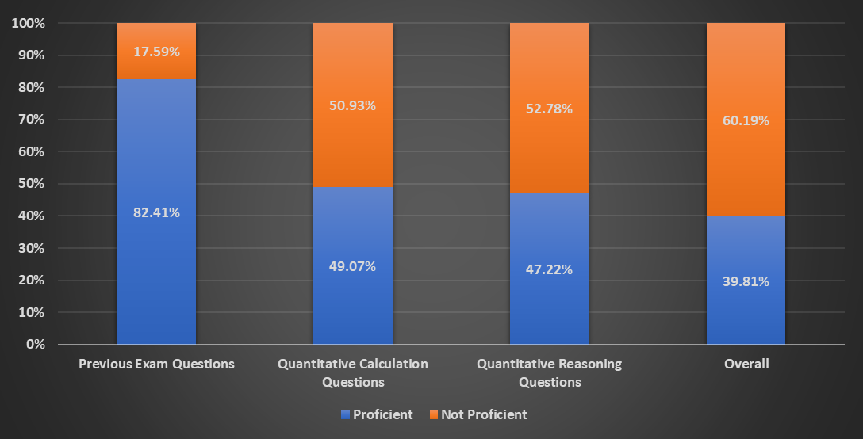

Figure 1. Proficiency test results – aggregated summary

**Results**

Of the 183 total students who took the exam, 64 tests were eliminated since these students were not at a point near graduation. A point of graduation is defined as being in their last three semester for graduation. Eleven tests were also eliminated because six students did not give consent to the release of their test results, and five students did not answer at least half of the questions. The remaining 108 qualified tests evaluated in four segments: previous quantitative reasoning exam, quantitative calculation, verbal quantitative reasoning, and weighted overall test results. For the questions taken from the 2017-18 Quantitative Reasoning Exam, 82% demonstrated proficiency and 18% did not. The evaluation of all the quantitative calculation test questions showed that 49% demonstrated proficiency and 51% did not demonstrate proficiency. The combination of these result is quite similar to the previous assessment which included heavily quantitative calculation questions, because half of Fresno State students were proficient in quantitative reasoning when they graduated based on 2017-2018 results. The evaluation of the verbal quantitative reasoning question results showed that 47% demonstrated proficiency and 53% did not demonstrate proficiency. Overall weighted assessment results for the exam showed that 40% of the students demonstrated proficiency in quantitative reasoning when they are near graduation. The overall weighted assessment results were disaggregated and analyzed to determine if there were any differences between specific groups. The chart below indicates that there are gaps in achievement between distinct groups including men and women. While 49% of men were deemed proficient, only 32% of women were proficient. Other differences in achievement parallel those that have previously been identified and discussed extensively in assessment literature. For example, only 31% of 1st generation college students were proficient but 57% of continuing generation students were proficient. Furthermore, only 36% of URM were proficient but 55% of white students were proficient. In addition, 42% of the transfer students were proficient. As expected, certain majors (including Science, Business School, and Engineering) had higher pass rates in quantitative calculation than others (such as Social Sciences, and Psychology majors). Since the majors with higher pass rates all include a calculus course and major courses which place an emphasis on calculations. However, the gap between the majors’ test results declined when we compare their success in verbal quantitative reasoning test results.

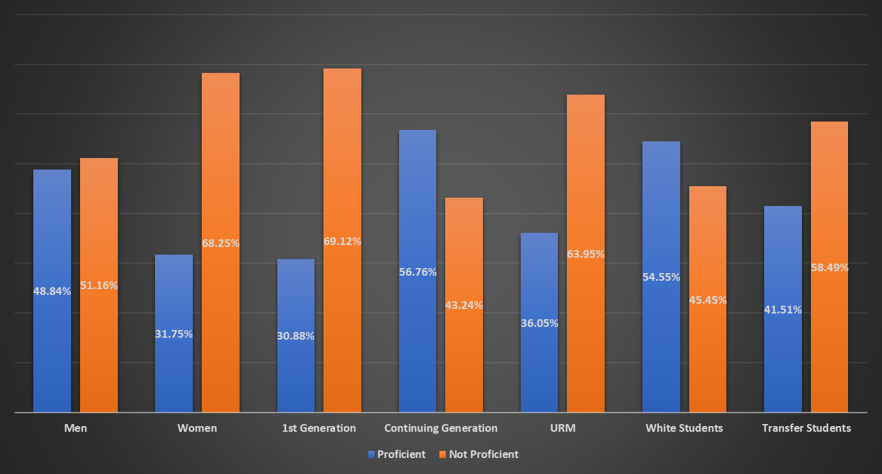

Figure 2. Quantitative Reasoning Overall Exam Results – disaggregated

**Discussion**

The results of the Quantitative Reasoning Exam demonstrated insufficient levels of student proficiency in Quantitative Reasoning at a point near graduation. There were also equity gaps in the assessment results. The results of the 2017-18 Quantitative Reasoning exam, based heavily on student calculations, also demonstrated insufficient levels of proficiency (51% proficiency). It is encouraging that the students performed at a higher level on the exam questions from the 2017-18 assessment that were repeated in this assessment (82% proficiency), the levels of proficiency on the new quantitative calculation questions (49% proficiency) and new quantitative reasoning questions (47% proficiency) were well below the 70% benchmark.

It is noteworthy that after the 2017-18 Quantitative Reasoning Exam, the Mathematics Department implemented increased supplemental instruction in lower division Math and Statistics courses and instituted curricular revisions for GE Quantitative Reasoning courses. The 2019-20 assessment of lower division B4 Quantitative Reasoning proficiency demonstrated favorable results. 100% of students were proficient at recognizing and explaining mathematical information, 92% of students were proficient at applying mathematical methods to real world situations, and 92% were proficient at using mathematical methods to find optimal results, make predictions, draw conclusions, and check to see if results are reasonable.

The results of the Quantitative Reasoning Exam were discussed by the College Assessment Coordinators. The College Coordinators observed that students demonstrated proficiency on their lower division quantitative reasoning GE assessment, but not on their upper division exam. This was similar to the pattern observed in Critical Thinking, with high levels of proficiency on the assessment of lower division A3 courses, but not on the Critical Thinking Core Competency Assessment. Conversely, the pattern was very different for the Oral Communication and Written Communication Core Competency Assessments. For those competencies, a high level of proficiency was demonstrated in the lower division GE Assessment of Oral Communication and Written Communication. Proficiency remained high on the Core Competency Assessments when students were at a point near graduation.

The College Assessment Coordinators observed that after taking their lower division GE courses in Oral and Written Communication, students continue to take courses where they are required to submit written assignments and deliver oral presentations. The Assessment Measures on twenty SOAPs from the eight Fresno State colleges were reviewed. All twenty SOAPs included written assignments and thirteen SOAPs included oral presentations. Only five SOAPs included assignments that focused on quantitative reasoning skills. It would facilitate student success in quantitative reasoning if this topic was reinforced in upper division classes, as is the case with Oral and Written Communication.

The committee also discovered that although some of the graphs on the exam were in color, when the exam was copied, it was printed in black and white. This made some of the questions more challenging, especially the question on interpreting margin of error. Additionally, more students than would be expected did not answer Question 10. It was sandwiched between Question 9 and 11 with very little space for students to answer. For future testing, the test should be reviewed prior to administration to ensure that the test is easy to read and has sufficient space for student responses.

To close the loop, the College Assessment Coordinators will collaborate with instructors who teach upper division courses that do incorporate quantitative reasoning in their assignments and other instructors with expertise in quantitative reasoning. The objective will be to develop units that teach and assess quantitative reasoning skills in upper division courses. Units will be developed for non-STEM courses and STEM classes. The units will be piloted in upper division courses and assessed. If successful, the units will be shared campus wide.

**QUANTITATIVE REASONING EXAM**

**Version A**

1. I give my consent for my results to be included in the collective results for the university and disaggregated into categories with the understanding that I will remain anonymous.

2. If one of your professors encouraged or required you to take this exam, please indicate the course and the professor’s name.

3. Please write your first and last name. This information will be provided to your professor after you complete the exam so you may receive credit for participating. This page will then be separated from the remainder of the exam and there will be no use of your name on the remainder of the exam.

**Student’s Information**

1. What is your major?

2. What is your anticipated graduation date?

Demographic Information

Fresno State’s goal is to promote success for all of our students. We collect demographic information about participants in this exam because we would like to determine whether there are any equity gaps in the results of this exam and celebrate student successes or work to eliminate any gaps that are found.

Providing demographic information is optional, you may omit any demographic question you do not wish to answer.

3. Are you a transfer student?

4. Are you a first-generation college student?

5. What is your gender identity?

6. How do you identify racially or ethnically?

1. **Quantitative Reasoning Exam (version 1)**
2. Solve X + 34 = 67

1. Suppose an admission ticket to a Lollapalooza Berlin Music Festival is 200 Euros, where 1 Euro is equivalent to $1.35 US dollars. What would the admission price be in US dollars?
   1. $130.50
   2. $140.80
   3. $270.00
   4. $350.00
2. Your grocery store has a 20 ounce jar of peanut butter for $4.00, and a 45 ounce jar for $9.00. Which purchase will get you the best price per ounce?
   1. The 20 ounce jar
   2. The 45 ounce jar
   3. The two jars are both the same price per ounce

Patrick’s bike ride follows a triangular path; two legs are equal, the third is 6 miles longer than the other legs. If Patrick rides 30 miles total, what is the length of the longest leg?

* 1. 6 miles
  2. 8 miles
  3. 14 miles
  4. 16 miles
  5. 18 miles

1. The manager of a farm is putting together a budget. The manager needs to buy 2 lbs of fertilizer and 1 lb of each pesticide. Choose the correct relationship about the following budget options:

|  |  |  |
| --- | --- | --- |
| Items | Quantity | Unit Value |
| **Fertilizer** |  |  |
| Fertilizer A | 2 lbs | $6/lbs |
| **Pesticide** |  |  |
| Pesticide B | 1 lbs | $2/lbs |
| Pesticide C | 1 lbs | $6/lbs |

* 1. The fertilizer costs more than the pesticides.
  2. The pesticides cost more than the fertilizer.
  3. Both fertilizer and pesticides costs are equal.
  4. The relationship cannot be determined from the information given.

1. A certain recipe requires 1.5 cups of sugar to make 2 dozen cookies. (1 dozen=12)

|  |  |
| --- | --- |
| Quantity A | Quantity B |
| The amount of sugar required for the same recipe to make 30 cookies | 2 cups of sugar |

* 1. Quantity A is greater.
  2. Quantity B is greater.
  3. The two quantities are equal.
  4. The relationship cannot be determined from the information given.

1. Explain why the following argument’s use of numbers does not adequately support the argument’s conclusions.

In 2020, the price of a dozen eggs was $3.50 on average in California. In January 2023, the price of a dozen eggs went up to $7.00 on average. This information shows that the cost of food increased by 100% from 2020 to 2023 for California households.

1. Questions that interpret data on graphs:

Poll results for the last 9 months:

Notes: Josh Jacobs (red line) vs. Devante Adams (blue line).

Background: Margin of error captures sampling variation: error that occurs because surveys are based on only a subset of the full population of likely voters. Even if this sample of respondents is selected randomly from the full population, it is not a perfect representation of attitudes in the full population. That’s where the usual 3 or 5 percent error rate comes from. For example, for election surveys, the sampling frame includes many adults who are not likely to vote. Pollsters try to correct for this by using likely-voter screens — typically asking respondents if they will vote — but this screen itself can introduce larger errors than the bias it was intended to correct (Source: The New York Times, 2016).

Question: Devante Adams and Josh Jacobs are running against each other to become the Mayor for Las Vegas, NV. The visual above shows the average poll results in the last 9 months inserted in one graph. The y-axis represents the percentage of the votes received by a candidate, and x-axis represents the months. The poll results show that Josh Jacobs (shown in Red) passed Devante Adams. However, the latest trends show that he is again losing the election based on the polls. Each line is accompanied by a margin of error in the shaded area around the line as plus or minus the margin of error (f(R) +/- ME). Given the margin of error, what can we conclude about this poll and possible election result?

1. Nate is taking a Business Administration course in supply chain management. The course meets MWF at 9:00. The syllabus indicates that there will be three pop quizzes during the semester. One pop quiz had been given in September and a second in October, with one more pop quiz remaining. If a student misses a pop quiz, they receive a zero. There are no make-up opportunities. It is now November and Nate is making plans for Thanksgiving break. During Thanksgiving week, the class will meet on Monday, but there is no class on Wednesday or Friday of that week. There will be two more weeks of classes after the break. Nate decides that he will skip class on the Monday of Thanksgiving week. Nate plans to graduate at the end of the fall semester and he will fail his Business Administration course if he gets a zero on the final pop quiz.

How risky would it be for Nate to miss class on the Monday of Thanksgiving week? Explain your answer.

1. Based on the trends shown by this line graph, will Tik Tok, Instagram, or Facebook have the most users in 2030? Explain your answer.

1. Jose has three finals next week and he is planning to study late into the night each day to get ready. He is stocking up on energy drinks for his study sessions. Jose could buy twelve individual cans of energy drinks for $2.19 each or he could buy a twelve pack of energy drinks for $19.29. How much money would Jose save if he bought a twelve-pack instead of twelve individual cans?
2. In 1861-62, California experienced a catastrophic “Great Flood.” The Sacramento and San Joaquin valleys turned into an inland sea and coastal areas in Los Angeles and Orange counties were flooded. These disastrous floods in California occurred about once every 200 years.

Scientists at the National Center for Atmospheric Research analyzed the effect of global warming on the likelihood of catastrophic flooding in California in the future. They concluded that due to climate change, a catastrophic flood would be likely to occur about three times every 100 years. Based on the scientists’ analysis, how many catastrophic floods would be expected in California during the next 200 years?

1. The results from the National Assessment of Educational Progress test offer the most definitive indictment of the pandemic’s impact on student learning. In the test’s first results since the pandemic began, math scores for eighth graders fell in nearly every state. A meager 26% of eighth graders were proficient in math, down from 34% in 2019. Reading scores also declined in more than half the states, a downward trend that had begun even before the pandemic.

Do these test results prove that the pandemic caused the decline in test scores in reading and math? Explain your answer.

1. In the 2001-02 academic year, tuition in the CSU system was $1428. In the 2022-23 academic year, tuition in the CSU system was $5742. Between 2001 and 2022, the cost of tuition increased by 402%, while the cost of living in the U.S. increased by 166%. How would you use this information to attempt to convince leaders in the CSU system that CSU tuition increase was unreasonable? How could leaders in the CSU system try to defend the tuition increase?
2. Two parallel lines. Calculate the value of angle θ

1. 110 b. 68 c. 70 d. 48 e. 40
2. Two standard six-sided dice are rolled. What is the probability that their sum is less than four?

1. 1/3 b. 1/4 c. 1/6 d. 1/12 e. 1/18
2. A hypothetical process flow chart is given for a loan application following two simultaneous processes. (The top and bottom processes happen at the same time while the customer is waiting for a decision). What is the total process time in minutes for a customer?

1. 30 min b. 45 min c. 50 min d. 55 min e. None of the above
2. The population of the city is 12,322. The total number of pounds of candy sold to these residents per year is 19,820. What is the average amount of candy each city resident buys per year?
3. 1.2 lbs b. 1.4 lbs c. 1.6 lbs d. 1.8 lbs
4. Abigail is an art student and wants to make a series of 10 paintings. Each 36 inches x 48 inches. Abigail has decided to build and stretch the canvas themselves. To do this they must order rolls of canvas and lumbar. Rolls of canvas are usually 40 inches wide by 6 yards long. Abigail will need 3 rolls of canvas to make 10 paintings. The lumber Abigail needs for the stretcher frames for their paintings come in 8 foot lengths. Each side of the frames for their stretched canvases must be a single continuous piece of lumber that is cut form the 8 foot length. Given that, Abigail will need 20 piece of lumber to construct the 10 stretcher frames. Let’s help Abigail figure out the cost for fabricating each of the 10 canvases. Using the following costs please find the per canvas total. Each roll of canvas costs $85 and each piece of lumber costs $6.50. How much does each canvas cost Abigail to make?
5. $36.5 b. $38.5 c. $40.5 d. $42.5
6. Maria is printing a series of screen printed posters for their friend’s band. The band wants 250 posters that include three colors. Maria needs to know how much the materials and labor will cost to create a quote for her friends band. Poster materials include 3 inks, paper, and a silkscreen for each color layer. Each sheet of paper can fit two posters side by side, Maria will need a gallon of each color, and three silkscreens. The poster paper costs $3.45 per sheet and it will cost $431.25 for the necessary paper to print 250 posters. The gallons of poster ink cost $89.99 per gallon for a total cost of $269.97. The special ordered Silkscreens will each cost $42.89 each plus $36 in freight for all three, costing $164.67. It will take Maria 10 hours to prepare the silkscreens and print the posters. Maria usually charges $50 per hour for labor but is giving their friend a discount of %50 off on the labor. Maria is charging their friend $250 for the 10 hours of labor. Combined with the material costs, how much does each poster cost on Maria’s quote?
7. $4.46 b. $4.50 c. $4.54 d. $4.58

**Alternate other four previous exam questions (version 2):**

1. The tuition at Fresno State’s bachelor program is currently $15,000 per year. For next year it will be raised by 30%. What will be the new tuition per year?
   1. 17,500
   2. 18,000
   3. 18,500
   4. 19,000
   5. 19,500
2. Joe is working a job where he makes $24,000 per year, paid out monthly at $2,000 per month. His employer tells him that he is going to get a 3% pay raise next year. What will he be making next year per month?
   1. $2,060
   2. $2,100
   3. $2,500
   4. $2,555
   5. $3,100
3. The original price of a sweater was $50. It is now on sale for 30% off. Calculate what the sale price would be for the sweater. Then decide which of the following coupons you should use to get the lowest final price.

a. A coupon for 30% off the sale price

b. A coupon for half the price of the original price.

c. A coupon for 10 dollars off the sale price

d. All three of these coupons would result in the same final price

1. Study the figure prior to choosing the response that best answers the following question: Which sectors of the economy (Services, Manufacturing, etc.) contributed more than at least three others in 2019 and also decreased their contribution to the arts by more than 5% between 2019 and 2022?

* 1. Manufacturing AND Retail
  2. Financial, Insurance, Real Estate AND Services
  3. Retail AND Wholesale
  4. Manufacturing AND Other
  5. Retail AND Other

**Answer Key (version 1):**

1. 33
2. c) $270.00
3. c) The two jars are both the same price per ounce
4. c) 14 miles
5. a) The fertilizer costs more than the pesticides.
6. b) Quantity B is greater.

Benchmark - Yes, egg prices increase 100% from 2020 to 2023

Milestone - No, egg prices increase 100% but we cannot connect one food price increase to all the food price increase.

Capstone - No, egg prices increase 100% but we cannot connect one food price increase to all the food price increase. Food prices fluctuate seasonally in different months since we cannot compare the whole year with a price in a month as well.

Benchmark - The poll shows that Devante Adams will win the election.

Milestone - We cannot determine who would win the election although Devante Adams is leading the poll.

Capstone - We cannot determine who would win the election since the margin of errors covers both candidates although Devante Adams is leading the poll.

Benchmark - “It is risky so Nate should not go.” or “It is not too risky so Nate can go.”

Milestone - The risk is 1/7. “Nate can go since there are two more weeks after Thanksgiving.” or “The risk might be high if Nate plans to graduate in Fall.”

Capstone - The risk is 1/7. Nate can reconsider his decision based on the previous quiz dates and instructor’s attitude for the holidays. For example, if the pop-quiz dates fall into the last week of a month, Nate should not go.

Benchmark - Facebook

Milestone - Tik Tok trend shows that it will catch Facebook by 2030.

Capstone - Explain details on graphs and possible changes in the trends.

Benchmark - Attempt to solve the problem

Milestone – Provides some quantitative analysis

Capstone – Uses calculation, list assumptions, and finds $6.99

Benchmark – Attempt to solve the problem and finds other than 6

Milestone – Provides some quantitative analysis and finds 6

Capstone – Finds 6 and explain some details about the probability.

Benchmark - Yes or No without any explanation.

Milestone - “No, since there are other factors that need to be evaluated.” or “Yes, since the change in math score percentage looks significant.”

Capstone - Yes or no with explanation on the other factors. Including, we do not have information on the change rate in reading scores since the other half of the state scores did not decline.

Benchmark - Percentage change in tuition is a lot higher than the cost of living.

Milestone - Percentage change in tuition is more than 2 times higher than the cost of living. However, the portion of educational expenses in the household budget is comparably lower than the other household expenses.

Capstone - Explain in detail about the benefits of higher education and increasing demand for education.

1. b) 68
2. d) 1/12
3. c) 50 min
4. c) 1.6 lbs
5. b) $38.5
6. a) $4.46

**Answer Key – alternate questions (version 2):**

1. e) 19,500
2. a) $2,060
3. a) A coupon for 30% off the sale price
4. a) Manufacturing AND Retail

Rubric adapted for Quantitative Reasoning Question Evaluations:

1. Fresno State has seven schools and colleges that focus on undergraduate students and the quantitative reasoning exam was given in five out of the seven (Arts and Humanities, Science and Math, Business School, Agricultural Sciences and Technology, and Engineering) and the sample is sufficiently representative of Fresno State students. The eighth school/college is the Kremen School of Education and Human Development and all of its programs and degrees, with the exception of liberal studies, are graduate programs, which is why this college is not directly involved in the process of assessing undergraduate core competencies.