California State University, Fresno
CHHS
Communicative Sciences and Deaf Studies, BA
Deaf Studies: Deaf Studies, Deaf Education, and Interpreting Options
Department/Program Assessment Coordinator [i]: Brooke Findley, Ed.D., CCC-SLP, BCBA
Student Outcomes Assessment Plan (SOAP)

Mission Statement
The Mission of the Department of Communicative Sciences and Deaf Studies at California State University, Fresno is to disseminate knowledge and to train professionals who will provide quality service to the public. The department will accomplish this mission by providing a stimulating learning environment for enhancing personal and educational development, promoting an understanding of people of various cultures, and offering opportunities for research and scholarship in communicative sciences and deaf studies.

Institutional Learning Outcomes, Program Learning Outcomes/Goals, and SLO’s [a,b,c]
  - Institutional Learning Outcomes. Fresno State ILO’s are posted on the following webpage: http://fresnostate.edu/academics/oie/assessment/fresno-state-assessment.html
1. Acquiring Specialized Knowledge
2. Improving Intellectual Knowledge
3. Applying Knowledge
  - Program Learning Outcomes and SLO’s
      - PLO: Demonstrate understanding and application of knowledge within their selected discipline/option.
        - SLO: Students will understand the social, emotional, linguistic, vocational and intellectual aspects of Deaf culture
        - SLO: Students will understand the basic process of teaching academics to children who are Deaf or hard of hearing
        - SLO: Students will understand theoretical foundations and technical skills needed to interpret in professional settings for children and adults who are Deaf or hard of hearing
      - PLO: Demonstrate proficiency in written communication
        - SLO: Demonstrate proficiency in writing by writing a professional report
      - PLO: Establish appropriate and measurable goals for potential clients or students
        - SLO: Students will assimilate and apply knowledge regarding normal and abnormal development, curriculum requirements, and instructional approaches
        - SLO: Students will apply their knowledge to establish appropriate and measurable goals and objectives for assigned clients and/or students
      - PLO: Communicate effectively with potential clients, students, or consumers
        - SLO: Students will communicate effectively with adults and children who are Deaf or hard of hearing using a variety of communication strategies
        - SLO: Students will synthesize and evaluate the communication environment and match their language to their clients
        - SLO: Students will demonstrate their effective communication skills using American Sign Language (ASL)
      - PLO: Demonstrate professional behavior within their selected discipline
        - SLO: Students will demonstrate professional behavior during their interactions with clients, students, and/or parents

Curriculum Map [d]: Courses in which SLO’s are addressed and evaluated
 | SLO 1.1 | SLO 1.2 | SLO 1.3 | SLO 2.1 | SLO 3.1 | SLO 3.2 | SLO 4.1 | SLO 4.2 | SLO 4.3 | SLO 5.1
CSDS  80 | I | I | I
Deaf  Studies  CSDS  90 | I
CSDS  93 | D |  | D |  |  |  | I | I | I
CSDS  94S | M |  | M |  |  |  | M | D | D | I
CSDS  95 | I | I | I
CSDS  96 | D |  | D |  |  |  | I | I | I
CSDS  98 | I |  | I |  |  |  |  |  |  | I
CSDS  106 | D | D | D |  | I |  | D | D | D
Deaf  Ed  CSDS  114 | I | I | I | I | I | I
CSDS  121 |  | D |  |  | D
CSDS  128 |  | D |  |  | D |  | D
CSDS  131 |  | D |  |  | D |  | D
CSDS  136S | M |  | M |  |  |  | M | D | D | D
CSDS  137 | M |  | M |  |  |  | M | D | D | D
CSDS  139 | D | D | D |  |  |  | D |  |  | D
CSDS  141 |  | D |  |  | D | D
CSDS  162 | D | D | D |  | D
CSDS  163 |  | M
CSDS  164 |  | M |  | M | M | M | M | M | M | M
Interpret  CSDS  166 | I |  | I
CSDS  168S | M |  | M |  |  |  | M | M | M | M
CSDS  169 | D |  | D
CSDS  170 | D |  | D |  |  |  | D | D | D
CSDS  175 | M | M | M | M | M | M | M | M | M | M
CSDS  188T | M |  | M |  |  |  | M | M | M | M

I = Introduced | D = Developed | M=Mastered

SLO’s Mapped to Assessment Measures and Methods [e]
Assessment Measure | Evaluation  Method | SLO 1.1 | SLO 1.2 | SLO 1.3 | SLO 2.1 | SLO 3.1 | SLO 3.2 | SLO 4.1 | SLO 4.2 | SLO 4.3 | SLO 5.1
Lesson Plans | Score | X | X |  |  | X | X
Evaluation of Lesson Presentation | Score | X | X |  |  | X | X | X | X | X | X
Evaluation of Interpreting Services | Score | X |  | X |  |  | X | X | X | X | X
Exit Questionnaire | Score | X | X | X | X | X | X | X | X | X | X

Assessment Measures: Description of Assignment and Method (rubric, criteria, etc.) used to evaluate the assignment [f]
  - Direct Measures (Department/Program must use a minimum of three different direct measures)
1. Lesson Plans: As a part of their CSDS 164 practicum, students are assigned to a school site one day a week for the semester. Within this practicum placement, students are graded on their ability to effectively develop a weekly lesson plan. Should at least 80% of students demonstrate satisfactory performance across relevant items on the practicum grading rubric (See Appendix A: CSDS 164 Practicum Evaluation Rubric), the individual SLOs mapped to this direct measure shall be considered met.
2. Evaluation of Lesson Presentation: As a part of their CSDS 164 practicum, students are assigned to a school site one day a week for the semester. Within this practicum placement, students are graded on their ability to effectively deliver a lesson to a classroom of students. Their supervisor grades the students on their teaching effectiveness, communication skills, quality of lesson plans and materials, implementation of suggestions, punctuality, and self-reflection skills. Should at least 80% of students demonstrate satisfactory performance across relevant items on the practicum grading rubric (See Appendix A: CSDS 164 Practicum Evaluation Rubric), the individual SLOs mapped to this direct measure shall be considered met.
3. Evaluation of Interpreting Services: As a part of their interpreting internship in CSDS 175, students are required to provide supervised interpreting services in a variety of professional settings. Students are evaluated on their professionalism, dependability, professional appearance, ability to work with others, ability to accept feedback, adherence to the professional code of conduct, ability to synthesize and evaluation situations, and tier interpretation and transliteration skills. Should at least 80% of students demonstrate satisfactory performance across relevant items on the practicum grading rubric (See Appendix B: CSDS 175 Rubric), the individual SLOs mapped to this direct measure shall be considered met.
  - Indirect Measures (Department/Program must use a minimum of one indirect measure)
1. Exit Questionnaire: Undergraduate students in their final semester will be asked to complete an exit questionnaire (See Appendix C: Exit Survey for Undergraduate Students). Should at least 80% of students indicate that they “agree” or “strongly agree” with relevant items on the exit survey, the individual SLOs mapped to this indirect measure shall be considered met.

Assessment Schedule/Timeline [g]
Measure | Year
 | 1  18/19 | 2  19/20 | 3  20/21 | 4  21/22 | 5  22/23
Lesson Plans | X |  | X
Evaluation of Lesson Presentation | X | X | X |  | X
Evaluation of Interpreting Services |  | X |  | X
Exit Questionnaire |  |  |  | X | X

Closing the Loop [h,j,k]
Fresno State Closing the Loop process is described immediately below.

A major assessment report, which focuses on assessment activities carried out the previous academic year, is submitted in September of each academic year and evaluated by the Learning Assessment Team and Director of Assessment at Fresno State.
Program/Department Closing the Loop process: Data is collected and analyzed according to the implementation schedule above. This information is then used to write a report, “Summary of Outcome Assessment Results,” for the academic year in which the data is collected. Shortly after the report is complied, it is presented to and reviewed by the departmental faculty. The findings are discussed and an action plan may be decided upon, as appropriate. If it is decided that an action needs to be taken or a change needs to be made, responsibilities are assigned. It is then up to the assessment coordinator to follow up on any actions or changes in terms of additional data collected in subsequent years. Examples of summary assessment result reports will clearly identify actions that have been taken and are available upon request.

List of Appendices
Appendix A: CSDS 164 Practicum Evaluation Rubric
Appendix B: CSDS 175 Rubric
Appendix C: Exit Survey

Appendix A: CSDS 164 Practicum Evaluation Rubric
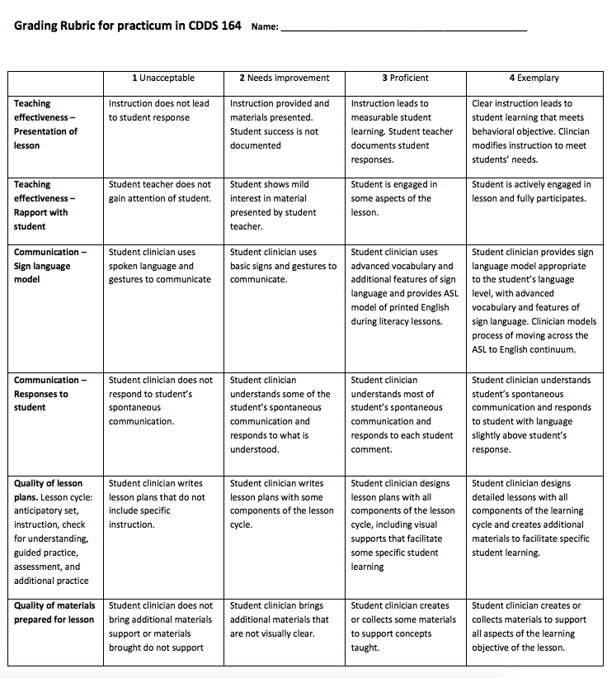
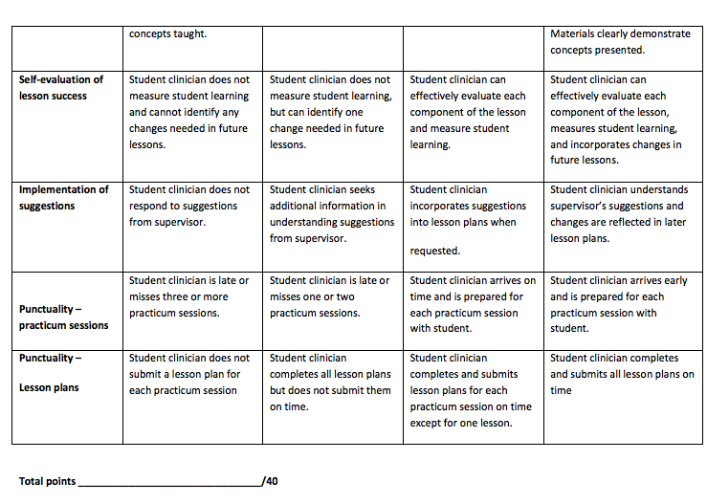

Appendix B: CSDS 175 Rubric
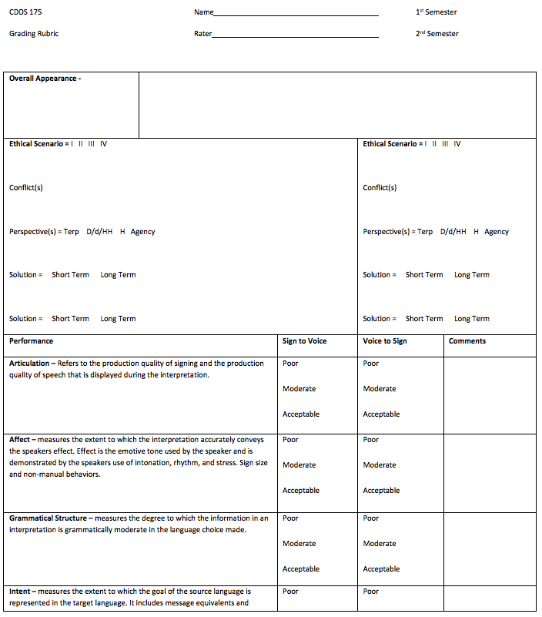
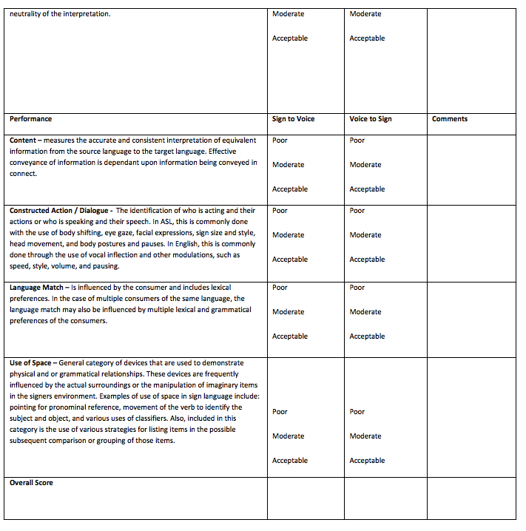

Appendix C: Exit Survey for Undergraduate Students
Our Undergraduate Exit Questionnaire is distributed as an on-line survey using “Qualtrics”. The students respond to each statement using a five point scale: “no opinion”, “strongly agree”, “agree”, disagree”, and “strongly disagree”. It includes the following statements:
1. The program provided me with the skills needed to write a professional report within my discipline.
2. The program provided me with the skills needed to assess an individual’s speech, language, auditory, and communication skills.
3. The program provided me with the skills needed to communicate effectively with potential clients, students, or consumers.
4. The program provided me with the skills needed to demonstrate professional behavior within my discipline.
5. The program provided me with the skills needed to establish appropriate measurable goals for potential clients or students.
6. The program provided me with an understanding of the physical basis for a speech or hearing problem.
7. I completed the requirements needed to apply to a graduate program in my selected field
Note: Interpreting students do not complete #5 or #6 as they are N/A for those students.
In addition, the survey contains a narrative area for students to comment on “any areas in the curriculum which affected their level of satisfaction with the program”.

