**STUDENT OUTCOMES ASSESSMENT PLAN (SOAP)**

Civil Engineering Program

**CALIFORNIA STATE UNIVERSITY, FRESNO**

Lyles College of Engineering

Department of Civil & Geomatics Engineering

2320 E San Ramon Ave, Fresno CA 93740-8030

March 2021

**TABLE OF CONTENTS**

|  |  |  |
| --- | --- | --- |
| **Section** |  | **Page** |
| I | Background | 1 |
| II | Program Mission Statement | 1 |
| III | Program Educational Objectives (PEOs) | 1 |
| IV | Student Outcomes | 2 |
| V | Curriculum | 4 |
| VI | Constituents | 8 |
| VII | Assessment Tools and Plans | 8 |
| VIII | Other | 18 |
| IX | Continuous Improvement | 18 |

**LIST OF FIGURES**

|  |  |  |
| --- | --- | --- |
| **Figure** |  | **Page** |
| 1 | Civil Engineering Program, Fresno State | 4 |
| 2 | Sample oral presentation rubric for CE180B (Fall 2012) | 11 |
| 3 | Number of graduating seniors passing the EIT exam | 12 |
| 4 | Sample student course survey | 14 |
| 5 | Sample exit interview survey | 16 |
| 6 | Sample alumni survey | 21 |
| 7 | Student outcomes assessment and continuous improvement loop | 23 |

**LIST OF TABLES**

|  |  |  |
| --- | --- | --- |
| **Table** |  | **Page** |
| 1 | Mapping of SOs to PEOs | 3 |
| 2 | Mapping of CE curriculum to student outcomes | 5 |
| 3 | Body-of-Knowledge assessment | 13 |
| 4 | Junior/senior survey | 15 |
| 5 | Assessment plan | 18 |

**I. BACKGROUND**

The Civil Engineering Program (CE Program or Program) at Lyles College of Engineering (LCOE), California State University, Fresno (or Fresno State), is an accredited program by the Accreditation Board for Engineering and Technology (ABET). The Program was visited by ABET in Fall 2018. The CE Program has earned national accreditation via the ABET Engineering Accreditation Commission until September 30, 2025. This SOAP details amongst others the Mission (**Section II**), Program Education Objectives or PEOs (**Section III**), Student Outcomes or SOs (**Section IV**), Curriculum (**Section V**), Constituents (Section **VI**), and Assessment Tools and Plans (**Section VII**), of the Program.

**II. PROGRAM MISSION STATEMENT**

The mission statement of the Program is as follows:

*The Civil Engineering Program at California State University Fresno, Fresno CA, strives to provide high quality education required for students to fully develop their professional qualities and skills as civil engineering, and to develop their personal potential to the greatest extent possible to serve the Central Valley and society at large.*

The mission statement has been adopted and its message is consistent to that of the Fresno State’s.

**III. PROGRAM EDUCATIONS OBJECTIVES**

The Program Educations Objectives (PEOs) are broad statements that describe the career and professional accomplishments that the Program is preparing graduates to achieve, and they are

1. **Technical Aptitude**: Be employed as engineers with the ability to use their technical knowledge, design, and problem solving skills for effective professional practice throughout their careers;
2. **Life-Long Development**: Exercise capabilities for life-long learning as a mean to enhance their technical and professional skills, to continuously enrich themselves and benefit the communities they are serving and beyond,
3. **Collaborative Spirit**: Develop interpersonal and collaborative skills that function well amongst a diverse group of professionals for a productive career; and
4. **Professional Advancement**: Advance and support the engineering profession through participation of professional societies, civic groups, and educational institutions; and/or establish a distinctive record of professional achievements.

These PEOs highlight the key traits the graduates of the Program should achieve three to five years of graduation.

**IV. STUDENT OUTCOMES**

The Program requires that students completing a Bachelor of Science in Civil Engineering (BSCE) degree to acquire the skills necessary to succeed in the engineering profession. The Student Outcomes (SOs), which are the skill sets describing what students are expected to know and are capable of doing by the time of graduation, as identified by the Program are[1]

(1) An ability to identify, formulate, and solve complex engineering problems by applying principles of engineering, science, and mathematics.

(2) An ability to apply engineering design to produce solutions that meet specified needs with consideration of public health, safety, and welfare, as well as global, cultural, social, environmental, and economic factors.

(3) An ability to communicate effectively with a range of audiences.

(4) An ability to recognize ethical and professional responsibilities in engineering situations and make informed judgments, which must consider the impact of engineering solutions in global, economic, environmental, and societal contexts.

(5) An ability to function effectively on a team whose members together provide leadership, create a collaborative and inclusive environment, establish goals, plan tasks, and meet objectives.

(6) An ability to develop and conduct appropriate experimentation, analyze and interpret data, and use engineering judgment to draw conclusions.

(7) An ability to acquire and apply new knowledge as needed, using appropriate learning strategies.

These SOs replace the previous version of SOs (*a* through *k*) as required by the ABET.

Table 1 shows how the SOs (**Section IV**) best match the PEOs (**Section III**).

**Table 1. Mapping of SOs (Section IV) to PEOs (Section III)**

|  |  |  |  |  |
| --- | --- | --- | --- | --- |
| **Student Outcomes** | **Program Educational Objectives** | | | |
| Technical Aptitude | Life-Long Development | Collaborative Spirit | Professional Advancement |
| (1) An ability to identify, formulate, and solve complex engineering problems by applying principles of engineering, science, and mathematics. | **●** | **●** |  | **●** |
| (2) An ability to apply engineering design to produce solutions that meet specified needs with consideration of public health, safety, and welfare, as well as global, cultural, social, environmental, and economic factors. | **●** |  |  | **●** |
| (3) An ability to communicate effectively with a range of audiences |  | **●** | **●** | **●** |
| (4) An ability to recognize ethical and professional responsibilities in engineering situations and make informed judgments, which must consider the impact of engineering solutions in global, economic, environmental, and societal contexts. |  | **●** |  | **●** |
| (5) An ability to function effectively on a team whose members together provide leadership, create a collaborative and inclusive environment, establish goals, plan tasks, and meet objectives. |  |  | **●** |  |
| (6) An ability to develop and conduct appropriate experimentation, analyze and interpret data, and use engineering judgment to draw conclusions. | **●** |  |  |  |
| (7) An ability to acquire and apply new knowledge as needed, using appropriate learning strategies. | **●** | **●** |  |  |

**V. CURRICULUM**

The curriculum leading to the BSCE degree requires 124 semester units (see Fig. 1), and is organized into: (a) major and additional requirements; (b) general education requirements; (c) other requirements and (d) sufficient elective units to meet required total units.



**Fig. 1. Civil Engineering Program, Fresno State.**

Table 2 below shows the correlations between the Curriculum of the Program (**Section V**) to SOs (**Section IV**).

|  |  |  |  |  |  |  |  |  |  |  |  |  |
| --- | --- | --- | --- | --- | --- | --- | --- | --- | --- | --- | --- | --- |
| **Table 2 (1 of 3) – Mapping of CE Curriculum to Student Outcomes** | | | | | | | | | | | | |
| **H** = High  **M** = Medium  **L** = Low  **Student Outcomes** | Math & Basic Sciences | General Education | GME15, L – Engineering Surveying & Laboratory | GME 66 – Computer Aided Mapping (or ME66 – Engineering Graphic) | ECE 91 – Electrical Circuit | ME112 – Engineering Mechanics: Dynamics | CE20 – Engineering Mechanics: Statics | CE85 – Introduction to CE | CE110 – Computer Applications in CE | CE121,L – Mechanics of Materials & Laboratory | CE123,L – Soil Engineering & Laboratory | CE124 – Concrete Laboratory |
| (1) Apply knowledge of math, science, & engineering principles | **H** |  | **H** | **L** | **H** | **H** | **H** | **M** | **H** | **H** | **H** | **M** |
| (2) Apply engineering design to produce solutions | **L** |  |  |  |  |  |  |  |  | **M** | **M** |  |
| (3) An ability to communicate effectively with a range of audiences | **M** | **H** | **M** | **L** | **L** | **L** |  |  |  | **L** | **L** | **M** |
| (4) Recognize ethical and professional responsibilities |  | **H** |  |  |  |  |  | **H** |  | **L** |  |  |
| (5) Function effectively on a team |  |  | **H** | **L** |  | **L** |  | **H** |  | **L** | **M** | **L** |
| (6) Develop and conduct experimentation, analyze and interpret | **H** |  |  | **M** |  |  |  |  |  | **H** | **H** | **H** |
| (7) Acquire and apply new knowledge as needed |  | **H** | **M** |  |  |  |  | **H** | **H** | **L** | **L** |  |

|  |  |  |  |  |  |  |  |  |  |  |  |  |
| --- | --- | --- | --- | --- | --- | --- | --- | --- | --- | --- | --- | --- |
| **Table 2 (2 of 3) – Mapping of CE Curriculum to Student Outcomes** | | | | | | | | | | | | |
| **H** = High  **M** = Medium  **L** = Low  **Student Outcomes** | CE128 – Civil Engineering Hydraulics | CE129 – Engineering Hydraulics Laboratory | CE130 – Theory of Structures | CE132 – Reinforced Concrete Design | CE133 – Steel Design | CE142,L – Environmental Engineering & Laboratory | CE150 – Transportation Planning & Design | CE161 – Construction Engineering | CE180A – Project Design | CE180B - Senior Project | CE185 – Civil Engineering Practice | CE125 – Geotechnical Engineering (Design Elec.) |
| (1) Apply knowledge of math, science, & engineering principles | **H** | **M** | **H** | **H** | **H** | **H** | **H** | **H** | **M** | **H** |  | **H** |
| (2) Apply engineering design to produce solutions | **M** |  |  | **H** | **H** | **H** | **H** |  |  | **H** |  | **H** |
| (3) An ability to communicate effectively with a range of audiences | **L** |  | **L** | **L** |  | **L** | **H** | **M** | **H** | **H** | **M** | **M** |
| (4) Recognize ethical and professional responsibilities |  |  |  |  |  |  |  | **M** | **M** | **H** | **H** |  |
| (5) Function effectively on a team |  | **L** | **M** | **L** |  | **H** | **H** |  | **H** | **H** |  | **M** |
| (6) Develop and conduct experimentation, analyze and interpret |  | **H** |  |  |  | **H** | **M** |  |  |  |  |  |
| (7) Acquire and apply new knowledge as needed | **M** | **M** | **L** | **L** |  | **L** | **H** | **L** | **M** | **H** | **M** | **L** |

|  |  |  |  |  |  |  |  |  |  |  |  |
| --- | --- | --- | --- | --- | --- | --- | --- | --- | --- | --- | --- |
| **Table 2 (3 of 3) – Mapping of CE Curriculum to Student Outcomes** | | | | | | | | | | | |
| **H** = High  **M** = Medium  **L** = Low  **Student Outcomes** | CE131 – Immediate Theory of Structures (Tech. Elec.) | CE134 – Foundation Engineering (Design Elec.) | CE136 – Design of Timber Structures (Design Elec.) | CE137 – Seismic Analysis of Building Structures (Tech. Elec.) | CE140 – Hydrology (Tech. Elec.) | CE141 – Water Resource Engineering (Design Elec.) | CE144 – Design of Water Quality Control Process (Design Elec.) | CE146 – Urban Storm Water Management (Design Elec.) | CE151 – Pavement Design (Design Elec.) | CE152 – Transportation Materials (Tech. Elec.) | CE153 – Traffic Operation and Controls (Tech. Elec.) |
| (1) Apply knowledge of math, science, & engineering principles | **H** | **H** | **H** | **H** | **H** | **H** | **H** | **H** | **H** | **H** | **H** |
| (2) Apply engineering design to produce solutions |  | **H** | **H** |  |  | **H** | **H** | **H** | **L** |  | **H** |
| (3) An ability to communicate effectively with a range of audiences |  | **L** |  |  |  | **L** | **L** | **L** | **L** | **L** | **L** |
| (4) Recognize ethical and professional responsibilities |  |  |  |  |  |  |  |  |  | **L** |  |
| (5) Function effectively on a team |  |  |  |  | **L** | **L** | **H** |  |  |  |  |
| (6) Develop and conduct experimentation, analyze and interpret |  |  |  |  |  |  |  |  |  |  |  |
| (7) Acquire and apply new knowledge as needed | **L** | **L** |  | **L** | **L** | **L** | **L** | **L** | **H** | **M** | **H** |

**VI. CONSTITUENTS**

The constituents of the CE Program include employers, alumni, engineering practitioners, advisory board, faculty members and students. The majorities of the constituents reside in California’s Central Valley and represent a diverse group of different ethnicities, economic and educational background.

The employers of the CE graduates include a wide range of entities from governmental agencies to private engineering consulting firms. The majority are located in the Central Valley. Employers include engineering design firms, consulting firms, and construction companies and contractors. The engineering firms vary in size form firms with 3 or 4 registered professional engineers to large ones owned by local engineers (some of them alumni of the CE Program) and large national and international firms with offices in the Central Valley. Also a large number of local or state agencies employ the graduates of the CE Program such as FHWA, EPA, California Department of Transportation, California Department of Water Resources, Fresno County, City of Fresno, City of Clovis, California Department of Forestry, Fresno Metropolitan Flood Control District, and many others.

The majority of the CE alumni stay in the Central Valley from where they came originally. The alumni constitute an important part of the professional engineer workforce in the local area with many of them holding positions of relevance and leadership both in the private industry and in local, state, or federal agencies.

The advisory board is made of practicing engineers with prominent professional positions in a diverse group of offices in the area. They represent the private and public sections; they represent small and large entities; some are alumni of the CE Program while others graduated from institutions other than Fresno State. Also, they represent different technical specialties within Civil Engineering.

**VII. ASSESSMENT TOOLS AND PLANS**

This section details the proposed assessment tools and plans for SOs (**Section IV**) for AY 2020/21 to 2024/25 (the next onsite WASC Review is scheduled to be in Spring 2021; and the next ABET review is anticipated to be 2024-2025 AY).

The proposed assessment tools are classified into two categories: ***direct*** and ***indirect*** assessment tools. The ***direct*** assessment tools include (a) culminating experience, (b) EIT certification at-time-of-graduation, and (c) Body-of-Knowledge score. The ***indirect*** assessment tools include (d) student course evaluation survey, (e) Junior/Senior survey, and (f) exit interviews. These assessment tools are explained further as follows:

1. *Culminating experience:* Completing a senior design project is the culminating experience for undergraduates in the CE Program curriculum. The senior project experience spans over two semesters. CE180A (2 units) is the first course in the senior design project sequence. The emphasis of CE180A is on design project proposal, project identification, design team formation (i.e., multi-disciplinary), and preliminary development of design alternatives and validations. CE180B is the second course in the senior design project sequence. The emphasis of CE180B is placed on the completion of a major design project initiated in CE180A. Each student in CE180B is paired and supervised by a faculty and a practitioner mentor throughout the entire design process. The deliverables for students in CE180B include progress reports, final project reports, design drawings, and presentations. An oral presentation scoring rubric for CE180B is presented in Fig. 2.
2. *EIT certification at-time-of-graduation*: The “Engineer-in-Training” (EIT) is a professional designation from *National Council of Examiners for Engineering and Surveying* (NCEES) used in the US to designate a person who has passed the 8-hour Fundamentals of Engineering (FE) examination – typically from an ABET accredited engineering program or equivalent. The California licensure Board of Engineers, Surveyors, and Geologists, permits students to take the FE exam prior to their final year. Passage of the FE exam (i.e., EIT certification) qualifies a candidate, as required by the California law, towards becoming licensed as a professional engineer (PE). Even though the Program does not require its students to pass the exam to graduate, passing the exam does signal achievement of certain technical competence by the students. Fig. 3 shows the percentage of graduating senior passing the exam in the last few years.
3. *Body-of-Knowledge score*: The Body of knowledge (BOK) or more accurately the *Civil Engineering Body of Knowledge for the 21st Century* is a written document published by the American Society of Civil Engineers (ASCE) highlighting the desired knowledge, skills, and attributes to be possessed by a practitioner in civil engineering. The aspiration of BOK is an improved engineering education and tougher requirement for licensure. The BOK is assessed by incorporating or embedding key question(s) in the final examination of selected courses in the CE Program. By correctly answering key question(s), students demonstrate the attainment of specific outcomes in BOK[2], most of which are consistent with ABET Outcomes. Table 3 shows the nature of the key questions and results of selected courses for BOK assessment.
4. *Student course evaluation survey*: A Student Course Evaluation is a survey developed and used by the CE Program to gauge the attainment of specific SOs. The rating system developed by the faculty is used to gauge the student satisfaction, which indirectly indicates the knowledge gained in a course. Fig. 4 shows a sample student course evaluation (a CE150 course evaluation is presented herein). Please note that the sample course evaluation, i.e., Fig. 4, employed the previous version of SOs (twenty SOs). This form of student course evaluation and its rating system will be updated to reflect the new (1) to (7) SOs.
5. *Junior/senior survey*: A Junior/Senior Survey is an opinion survey, similar to the one used for Student Course Evaluation (see Fig. 4), to gauge the attainment of specific SOs. The survey represents a simple mean of gauging how satisfied students are with the Program as they progress through ranks and as they gain more understanding of engineering the profession or practice. Table 4 shows the students’ satisfaction with the CE Program when it showed they gained favorable of the Program as seniors. Again, this survey will be updated to reflect the newly adopted SOs [from (1) to (7)].
6. *Exit interviews*: The exit interview is an opinion survey of graduating students to gauge the attainment of specific SOs. The survey is a snap-shot of opinions of graduating students regarding the established SOs. Fig. 5 shows a sample of the said survey.

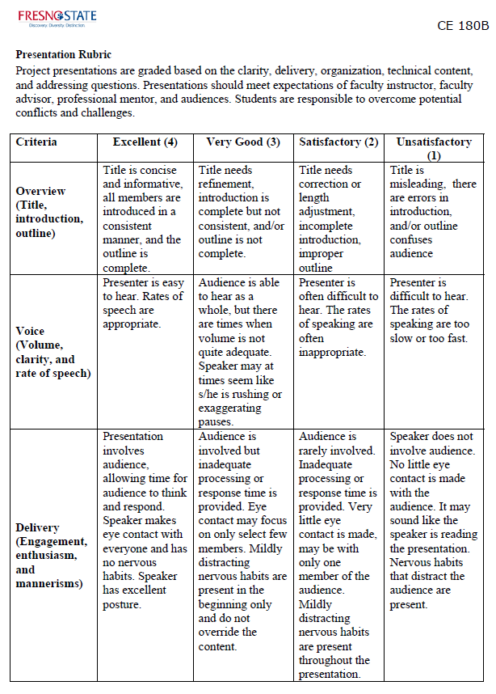

**Fig. 2. Sample oral presentation rubric for CE180B.**

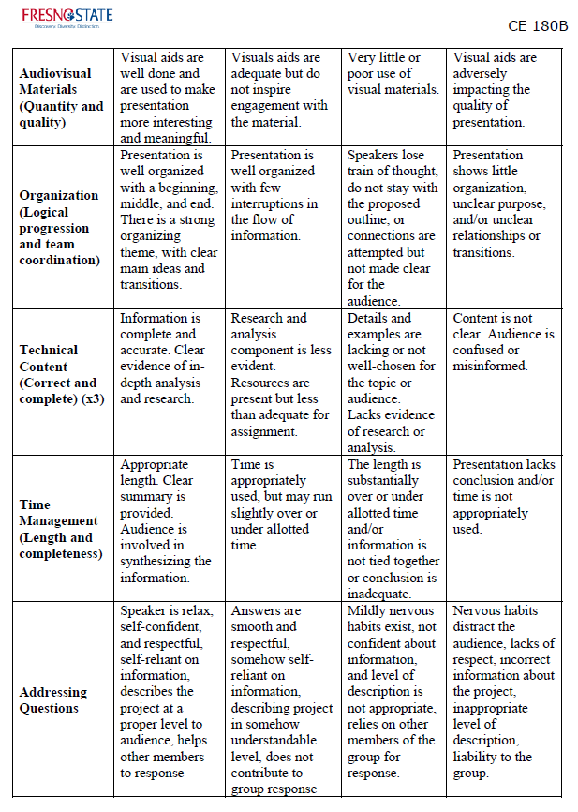

**Fig. 2 (Cont’d). Sample oral presentation rubric for CE180B.**

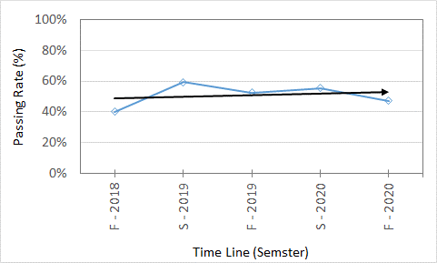

**Fig. 3. Number of graduating seniors passing the EIT exam.**

**Table 3. Body-of-Knowledge assessment**

|  |  |  |  |  |  |  |  |  |  |
| --- | --- | --- | --- | --- | --- | --- | --- | --- | --- |
| **Course Number/Title** | **Nature of BOK Questions** | **Assessment technique** |  |  |  | **Timeline** |  |  |  |
| **Spring**  **2021** | **Fall 2021** | **Spring**  **2022** | **Fall 2022** | **Spring**  **2023** | **Fall 2023** | **Spring 2024** |
| CE 85: Introduction to Civil Engineering | Ethics in professional practice | One question in final | - | Yes | - | Yes | - | Yes | - |
| CE 20: Engineering Mechanics: Statics | Static equilibrium and applications | Final exam | - | Yes | - | Yes | - | Yes | - |
| CE 123: Soil Engineering | Soil classification | One problem in final | Yes | - | Yes | - | Yes | - | Yes |
| CE 128: Civil Engineering Hydraulics | Application of Bernoulli’s principle in fluid dynamics | One problem in final | Yes | - | Yes | - | Yes | - | Yes |
| CE 130: Theory of Structures | Shear and bending moment in beams and frames | One problem in final | Yes | Yes | Yes | Yes | Yes | Yes | Yes |
| CE 142: Environmental Engineering | Mass balance & alkalinity | Average of two problems in final | Yes | Yes | Yes | Yes | Yes | Yes | Yes |
| CE 150: Transportation Planning and Design | Profile calculations for vertical curve design | One problem in final | Yes | Yes | Yes | Yes | Yes | Yes | Yes |
| CE 132: Reinforced Concrete Design | Reinforced concrete columns under uniaxial bending | One problem in final | Yes |  | Yes |  | Yes |  | Yes |

|  |  |  |  |
| --- | --- | --- | --- |
| **Course**: *CE 150* (Spring 2021)  *Transportation Planning and Design*  **Course Type**: *Two 50 min lecture/week, and one 2-hour and 50-min lab/week*  **Assessment techniques**: *Homework; quizzes & exams; individual & team design project/term paper*  **Specific Course Outcomes**:   * *Students will acquire the fundamental knowledge of transportation engineering, especially land transportation in highway and street systems* * *Students will know how to do the geometric design of roadways, streets, intersections, and roundabouts* * *Students will know how to mitigate the negative impact of transportation activities on the environment* * *Students will know how to analyze and design for highway, freeway, and intersection capacity* * *Students will acquire a basic knowledge of statistical analysis of traffic data* | | | |
| SO  (Abbreviated description of relevant SOs pertaining to the course under evaluation is provided) | Course Rating (0 to 5) | | |
| Faculty Expectation | Student Evaluation | Difference |
| Q1. *Apply knowledge of math, science, & engineering principles.* |  |  |  |
| Q2. *Apply engineering design to produce solutions* |  |  |  |
| Q3. *An ability to communicate effectively with a range of audiences.* |  |  |  |
| Q4. *Recognize ethical and professional responsibilities.* | -N/A- | | |
| Q5. *Function effectively on a team* |  |  |  |
| Q6. *Develop and conduct experimentation, analyze and interpret* |  |  |  |
| Q7. *Acquire and apply new knowledge as needed* |  |  |  |
| **Average** |  |  |  |
| Instructor’s notes/summary: | | | |

**Fig. 4. Sample student course survey**

**Table 4. Junior/Senior Surveys**

|  |  |  |  |  |  |  |  |  |  |  |  |  |  |  |  |
| --- | --- | --- | --- | --- | --- | --- | --- | --- | --- | --- | --- | --- | --- | --- | --- |
| **SO** | **Spring 2021** | | | | | **Spring 2023** | | | | | **Spring 2025** | | | | |
| **Juniors** | | **Seniors** | | Change  (2) – (1) | **Juniors** | | **Seniors** | | Change  (4) – (3) | **Juniors** | | **Seniors** | | Change  (6) – (5) |
| Average Rating  (1) | Average SD | Average Rating  (2) | Average SD | Average Rating  (3) | Average SD | Average Rating  (4) | Average SD | Average Rating  (5) | Average SD | Average Rating  (6) | Average SD |
| Q1. *Apply knowledge of math, science, & engineering principles.* |  |  |  |  |  |  |  |  |  |  |  |  |  |  |  |
| Q2. *Apply engineering design to produce solutions* |  |  |  |  |  |  |  |  |  |  |  |  |  |  |  |
| Q3. *An ability to communicate effectively with a range of audiences.* |  |  |  |  |  |  |  |  |  |  |  |  |  |  |  |
| Q4. *Recognize ethical and professional responsibilities.* |  |  |  |  |  |  |  |  |  |  |  |  |  |  |  |
| Q5. *Function effectively on a team* |  |  |  |  |  |  |  |  |  |  |  |  |  |  |  |
| Q6. *Develop and conduct experimentation, analyze and interpret* |  |  |  |  |  |  |  |  |  |  |  |  |  |  |  |
| Q7. *Acquire and apply new knowledge as needed* |  |  |  |  |  |  |  |  |  |  |  |  |  |  |  |
| Overall Average Change = | | | | |  | Overall Average Change = | | | |  | Overall Average Change = | | | |  |

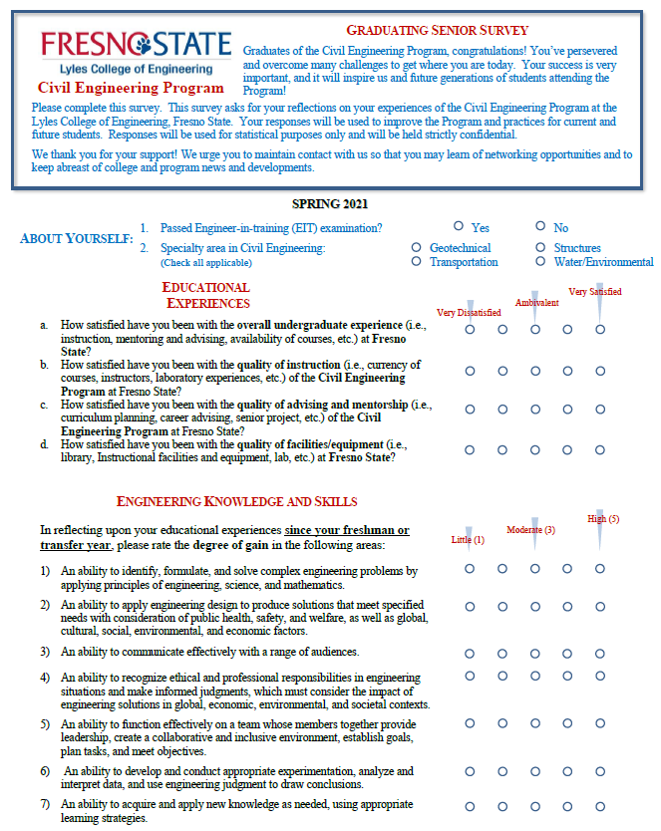

**Fig. 5. Sample exit interview survey**

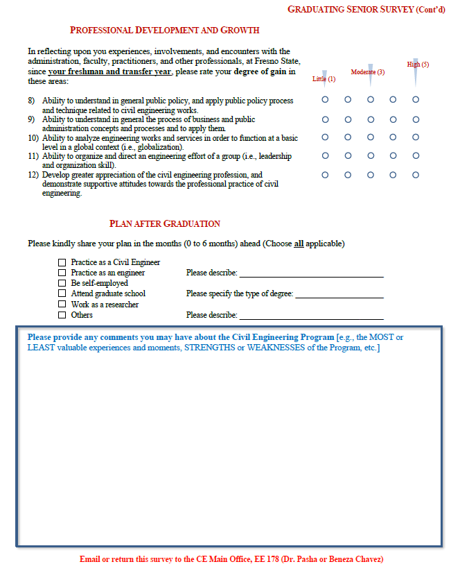

**Fig. 5 (Cont’d). Sample of exit interview survey**

The timetable of Table 5 shows when the proposed assessments will be carried out

**Table 5. Assessment plan**

|  |  |  |  |  |  |  |  |  |  |
| --- | --- | --- | --- | --- | --- | --- | --- | --- | --- |
|  | **Type** | **Technique** | **Timeline (Year)2** | | | | | | **Frequency** |
| 2019 | 2020 | 2021 | 2022 | 2023 | 2024 |
| **SOs1** | **“*Direct*”** | Culminating Experience (CE180A and CE180B) | (**F**)  (**S**) | (**F**)  (**S**) | (**F**)  (**S**)  (**F**)  (**S**)  (**F**)  (**S**)  (**F**)  (**S**)  (**F**)  (**S**)  (**F**)  (**S**) | (**F**)  (**S**) | (**F**)  (**S**) | (**F**)  (**S**) | Semester |
| EIT Certification at Time of Graduation | (**F**)  (**S**) |  |  |  |  |  | Semester |
| Body of Knowledge (BOK) Score | ??? | ??? | (**F**)  (**S**) | (**F**)  (**S**) | (**F**)  (**S**) | (**F**)  (**S**) | Annual |
| **“*In*d*irect*”** | Student Course Evaluation Survey | ??? | ??? | (**F**)  (**S**) | (**F**)  (**S**) | (**F**)  (**S**) | (**F**)  (**S**) | Annual |
| Junior/Senior Survey | ??? | ??? |  | (**S**)  (**F**)  (**S**)  (**F**)  (**S**) |  |  | Annual |
| Exit Interviews | (**F**)  (**S**) | (**F**)  (**S**) | (**F**)  (**S**) | (**F**)  (**S**) | (**F**)  (**S**) | (**F**)  (**S**) | Semester |
| **NOTES:**  1 The SOs are as defined in Section IV  2 (F) = Fall semester & (S) = Spring semester | | | | | | | | | |

**Table 6. The following schedule will be used to conduct Student Course evaluation and Junior/Senior Survey**

|  |  |  |  |  |  |  |  |  |  |  |  |  |  |  |  |  |  |  |  |  |  |  |  |
| --- | --- | --- | --- | --- | --- | --- | --- | --- | --- | --- | --- | --- | --- | --- | --- | --- | --- | --- | --- | --- | --- | --- | --- |
| Academic Year | Semester | CE 20 | CE 85 | CE 110 | CE 121 | CE 121L | CE 123 | CE 123L | CE 124 | CE 128 | CE 129 | CE 130 | CE 132 | CE 133 | CE 142 | CE 142L | CE 150 | CE 161 | CE 125 | CE 136 | CE 141 | CE 145 | CE 151 |
| 2020/21 | Spring | 1 |  | 1, 7 |  |  | 1, 2, 5, 6 |  |  | 1, 2, 7 |  | 1, 5 | 1, 2 |  |  |  | 1, 2, 3, 5, 7 |  |  |  |  |  |  |
| 2021/22 | Fall |  | 4, 5, 7 |  | 1, 2, 6 | 1, 2, 6 |  | 1, 2, 5, 6 | 1, 3, 6 |  | 1, 6, 7 |  |  | 1, 2 | 1, 2, 5, 6 | 1, 2, 5, 6 |  | 1, 3, 4 | 1, 2, 3, 5 | 1, 2 | 1, 2, 7 | 1, 2, 5 | 1, 7 |
| Spring | 1 |  | 1, 7 |  |  | 1, 2, 5, 6 |  |  | 1, 2, 7 |  | 1, 5 | 1, 2 |  |  |  | 1, 2, 3, 5, 7 |  |  |  |  |  |  |
| 2022/23 | Fall |  | 4, 5, 7 |  | 1, 2, 6 | 1, 2, 6 |  | 1, 2, 5, 6 | 1, 3, 6 |  | 1, 6, 7 |  |  | 1, 2 | 1, 2, 5, 6 | 1, 2, 5, 6 |  | 1, 3, 4 | 1, 2, 3, 5 | 1, 2 | 1, 2, 7 | 1, 2, 5 | 1, 7 |
| Spring | 1 |  | 1, 7 |  |  | 1, 2, 5, 6 |  |  | 1, 2, 7 |  | 1, 5 | 1, 2 |  |  |  | 1, 2, 3, 5, 7 |  |  |  |  |  |  |
| 2023/24 | Fall |  | 4, 5, 7 |  | 1, 2, 6 | 1, 2, 6 |  | 1, 2, 5, 6 | 1, 3, 6 |  | 1, 6, 7 |  |  | 1, 2 | 1, 2, 5, 6 | 1, 2, 5, 6 |  | 1, 3, 4 | 1, 2, 3, 5 | 1, 2 | 1, 2, 7 | 1, 2, 5 | 1, 7 |
| Spring | 1 |  | 1, 7 |  |  | 1, 2, 5, 6 |  |  | 1, 2, 7 |  | 1, 5 | 1, 2 |  |  |  | 1, 2, 3, 5, 7 |  |  |  |  |  |  |

All of the courses will be assessed by the first three academic years of the 6-year review cycle and data will be analyzed to adjust the course practices based on the assessment results. The fourth (2022/23) academic years will be used to process and adjust course practices based on an in-depth review of the assessment data from the previous years. The assessment process will then repeat in 2023/24 academic year. Data will be compiled in the final year (2024/25) of the 6-year cycle for the ABET visit happening that year.

**VIII OTHER**

The Program also conducts Alumni survey. The survey targets those graduated within one-to-three year period only. Therefore, for the ABET review period of 2006-2012, two such surveys were conducted: one ending in 2009, and the other ending in 2012 (just right before ABET visit). The survey is designed to primarily gauge the graduates’ opinion on PEOs. There are however questions in the survey that pertain to SOs. Fig. 6 shows a sample of such survey; Question 10 in this survey relates to SOs. Table 5 shows the results of Question 10 of the survey of the last two periods.

**IX CONTINUOUS IMPROVEMENT**

The curriculum of the CE Program is designed to ensure the fulfillment of the mission, program educational objectives (PEOs), and student outcomes (SOs). To provide the highest of quality for its consumers (the students) the Program continues to undergo rigorous, comprehensive, and periodic internal as well as external reviews. Its quality is evident by it continued ABET accreditation.

Suggestions for changes and/or improvement to the Program often initiated at the programmatic level (Chair and faculty members). They are then presented to the advisory board for discussion and consensus building, before formal adoption and implementation. This SOAP provides the template showing how the entire process is executed; including what, how, and when each step is taking place. This *continuous improvement* strategy has allowed the Program to function effectively and timely manner in addressing the changing needs of the civil engineering profession and for its students, and it will continue to do for a long time to come (A complete continuous improvement loop is presented in Fig. 7).

**Alumni Survey**

**CSU Fresno**

**Lyles College of Engineering**

1. When did you graduate from CSU-Fresno?

(month. year) ________________________

2. Current job title: ____________________

Current Salary (optional)________________

Name and Address (optional)_____________

__________________________________

__________________________________

3. Current employer: _____________________

4. In what field do you work?

_____ Industry

_____ Government

_____ Private Practice/consulting

_____ Education

_____ Construction

_____ Other: ______________________

5. Indicate your present employment status:

_____ Employed full‑time

_____ Full‑time graduate student

_____ Temporarily not employed

Reason: ____________________

_____ Working in another field

Reason:_____________________

Do you intend to return to your

field?

___ Yes ____ No ____ Not sure

_____ Other, please explain:_____________________

6. Please rank your professional success level:

_____ Very successful

_____ Successful

_____ Average

_____ Unsuccessful

Please explain briefly: ___________________

_____________________________________

_____________________________________

7. As you compare yourself to other beginning

professionals in your field, how do you rate the quality of your educational preparation in Civil Engineering?

_____ Far higher than average

_____ Higher than average

_____ Average

_____ Lower than average

_____ Far lower than average

8. Please rank the overall quality of your General Education coursework (arts, humanities, and social science courses).

___ Excellent ___ Good ___ Average ___ Poor

9. Using the following scale, please rate the following items relative to your education at the College of Engineering.

**weak ----> strong**

1 2 3 4 5

|  |  |  |  |  |  |
| --- | --- | --- | --- | --- | --- |
| a. Overall quality of your education |  |  |  |  |  |
| b. Overall quality of your laboratory coursework |  |  |  |  |  |
| c. Support, assistance, and general help from the CECS |  |  |  |  |  |
| d. Support, assistance and general help you received from faculty outside the CECS |  |  |  |  |  |
| e. How confident and prepared you felt in handling professional tasks when you left CSU-Fresno |  |  |  |  |  |
| f. How confident and prepared you feel in handling professional tasks now |  |  |  |  |  |
| g. If you participated in the co‑op or internship program, please rate the overall quality of your experience |  |  |  |  |  |

**Fig. 6. Sample alumni survey.**

10. Using the following scale, please indicate the

degree to which your education provided you

with the ability to:

**weak ----> strong**

1 2 3 4 5

|  |  |  |  |  |  |
| --- | --- | --- | --- | --- | --- |
| i. Apply knowledge of math, science and engineering |  |  |  |  |  |
| ii. Design and conduct experiments |  |  |  |  |  |
| iii. Design a system, component or process to meet desired needs |  |  |  |  |  |
| iv. Function on multi‑disciplinary teams |  |  |  |  |  |
| v. Identify, formulate, and solve technical problems |  |  |  |  |  |
| vi. Understand professional and ethical responsibility |  |  |  |  |  |
| vii. Communicate effectively (written and oral) |  |  |  |  |  |
| viii. Understand the impact of your practice in a global context |  |  |  |  |  |
| ix. Continue self-learning and continuing education |  |  |  |  |  |
| x. Understand and be aware of contemporary issues |  |  |  |  |  |
| xi. Use the techniques, skills, and modern technology tools necessary for your practice |  |  |  |  |  |
| xii. Work independently |  |  |  |  |  |

11. Do you think that any aspects of your program of study at CSU-Fresno should be modified?

____ yes ____ no

If yes, explain:

12. What changes do you foresee in your field in the next ten years? How might CSU-Fresno address these changes?

13. Please identify the areas in your program of study that contributed **LEAST** to your professional development. Such areas might include a specific course or specific course content, specific lab or field experience, specific instructional equipment, etc. Please explain.

14. To follow up on question 14, please identify the areas in your program of study that contributed **MOST** to your professional development.

**Fig. 6 (Cont’d). Sample alumni survey.**

**Table 5. Sample Summary Sheet of Alumni Survey: Period 2021-22 and 2023-24**

|  |  |  |  |  |
| --- | --- | --- | --- | --- |
| **Question 10** | **Period 2021-22** | | **Period 2023-24** | |
| **Average Rating** | **Standard Deviation** | **Average Rating** | **Standard Deviation** |
| i. Apply knowledge of math, science and engineering |  |  |  |  |
| ii. Design and conduct experiments |  |  |  |  |
| iii. Design a system, component or process to meet desired needs |  |  |  |  |
| iv. Function on multi‑disciplinary teams |  |  |  |  |
| v. Identify, formulate, and solve technical problems |  |  |  |  |
| vi. Understand professional and ethical responsibility |  |  |  |  |
| vii. Communicate effectively (written and oral) |  |  |  |  |
| viii. Understand the impact of your practice in a global context |  |  |  |  |
| ix. Continue self-learning and continuing education |  |  |  |  |
| x. Understand and be aware of contemporary issues |  |  |  |  |
| xi. Use the techniques, skills, and modern technology tools necessary for your practice |  |  |  |  |
| xii. Work independently |  |  |  |  |
| Note:  A rating of 3.5/5.0 scale is deemed satisfactory by the Program. | | | | |

Culminating Experience

EIT Data

Body of Knowledge

Course Evaluation

**SO Assessments**

Junior/Senior Survey

Exit Survey

***Chair and Program Assessment Coordinator***

**Survey Generation**

**Survey Review**

**(By Faculty)**

**Survey Review**

**(By Advisory Board)**

**Data Reduction & Analysis**

**Result Presentation**

**(To Faculty)**

**Result Presentation**

**(To Advisory Board)**

**Action Item(s)**

**Fig. 7. Student outcomes assessment and continuous improvement loop.**

1. The student outcomes are taken directly from ABET’s *Criteria for Accrediting Engineering Programs, 2020 – 2021*.
2. ASCE, Civil Engineering Body of Knowledge for the 21st Century (2nd Edition), 2008