Department of Economics
Economics major assessment Report for AY 2016-2017

What learning outcomes did you assess this year?
The Department of Economics assessed the following student learning outcomes (SLOs):
Economic Competencies (SOAP GOAL 1):
- Students will interpret assumptions behind different economic perspectives or paradigms. (SOAP SLO 1.4)
- Students will apply/use the formal language and concepts of the discipline (theory & praxis) to issues of contemporary and historical relevance. (SOAP SLO 1.5)
Critical Thinking (SOAP GOAL 3):
- Students will evaluate contrasting models/paradigms to identify key points of consensus and divergence on issues of contemporary and/or historical relevance. (SOAP SLO 3.1)
Communication Skills (SOAP GOAL 4)
- Students will demonstrate proficiency in writing knowledgeably, coherently, and persuasively on an array of conceptual and/or real, contemporary and/or historical topics related to the discipline. (SOAP SLO 4.1)
Application of Economics (SOAP GOAL 5)
- Students will practice independent economic research, including—but not limited to— use of professional and scholarly resources, secondary source materials, and statistical/econometric analyses. (SOAP SLO 5.1)
Social Awareness and Responsibility (SOAP GOAL 6)
- Students will identify the economic causes and consequences of social stratification and describe the policy decisions/processes used to address these. (SOAP SLO 6.1)

What instruments did you use to assess them?

Course Embedded Assessment (SLOs 1.4, 1.5, 3.1, and 4.1)
ECON 115T Topics in Historical & Political Economics was offered for the first time in Fall 2016 by Dr. Janice Peterson. Thirty-two students completed the course, all of whom were Economics majors or minors (two were international students from Germany). According to the course syllabus, “The course will introduce research on contemporary labor market trends and issues, as well as alternative theoretical perspectives, U.S. economic history, industry studies, descriptive statistics, and the stories and experiences of individual workers.”
In Fall 2016, Students completed four in-class writing assignments over the course of the semester (which, taken together, accounted for 80% of the course grade). Two of the assignments (Assignment 1 and 4) addressed all four SLOs (SLOs 1.4, 1.5, 3.1, and 4.1), while two of the assignments (Assignments 2 and 3) addressed only SLO 1.5 and SLO 4.1. The ECON 115T assessment activity was based on these four in-class writing assignments.
This assessment instrument was adapted from the Economics Department at California State University, San Bernardino (CSUSB) and revised by Dr. Peterson (Dr. Peterson was invited to serve as the outside reviewer for their Program Review in February 2016). For the revised assessment approach, Dr. Peterson rated each student, for each of the applicable SLOs, for each assignment throughout the semester. The assessment scoring rubric was completed for each student, for each assignment, after the grades for the assignment had been determined and recorded. (Please see Appendix A for the scoring rubric). Dr. Peterson constructed summary scores (based on the four individual assignment assessments) for each student, and then summarized the results for the class.
Surveys for Service-Learning Projects (SLOs 1.5, 4.1, and 5.1)
In the summer 2016 semester, Dr. Qin Fan worked with the Jan & Bud Richter Center for Community Engagement and Service-Learning and redesigned the upper-division course ECON 119 Urban and Regional Economics by adding a service-learning (SL) component as an option. In the redesigned course, students could choose either individual research (IR) project under the supervision of the instructor or SL project that requires a minimum of 15 community service hours, which accounts for 30% of the total grade.

During the last week of class, students completed an anonymous survey in class about their experience in the SL project. (Please see Appendix B for the survey). The survey questions are designed to assess three SOAP SLOs (question #1 for SLO 1.5; question #2 for SLO 5.1; and question #4 for SLO 4.1) along with other SL outcomes.

To better assess the value of SL project, students were divided in two groups. The treatment group consists of students who selected the SL project, while the control group comprises students who chose the IR project. A balanced data sample was collected with 13 responses from students who selected the SL project and 15 responses from students who chose the IR project.

Senior survey (SLOs 1.4 and 5.1)
To assess the SLOs 1.4 and 5.1, Drs. Gil Kim and David Vera developed a “Senior Survey” incorporating feedback from Department colleagues. The survey was deployed through Qualtrics starting in Spring 2014 and continues every spring going forward. The survey asks graduating seniors and recent graduates to respond to various questions regarding their experiences in Economics courses as well as their overall satisfaction with the program. As pertaining to the Student Outcome Assessment Plan (SOAP), two specific survey questions are in line with SOAP SLOs and goals. (Please see Appendix C for these two specific survey questions).
The survey received 3 responses in Spring 2016. To promote participation and response rate in Spring 2017, the Department offered a drawing for two $25 gift cards from the Kennel Bookstore, which was embedded to the end of the survey. As a result of the expanding efforts, a total of 20 responses were received in Spring 2017.

Writing assignments (SLOs 4.1, 5.1, and 6.1)
Writing assignments for the course ECON 146 Economics of Crime, which were submitted by students through Turnitin, were collected at the end of Fall 2016 semester by Dr. Va Nee Van Vleck. To assess the specific SLOs as stated above (SLOs 4.1, 5.1, and 6.1), a writing assignment checklist was created, which is in line with the three specific SLOs. Rating scales comply with the writing rubric used for course grading (see Appendix D for the writing assessment checklist). 34 students submitted the writing assignments. Dr. Qin Fan randomly assigned numbers from 1 to 34 to the students and used the number to anonymously rate the applicable SLO on the checklist. Dr. Fan rated each individual student’s assignment, for each of the applicable SLOs, and then summarized the results for the class.

What did you discover from the data?
Course Embedded Assessment (ECON 115T Topics in Historical & Political Economics)
At the conclusion of the semester (shortly after submitting final course grades), Dr. Peterson constructed summary scores (based on the four individual assignment assessments) for each student, and then summarized the results for the class. The summary results are:
SLOs | Excellent | Good | Competent | Fair | Poor
SLO 1.4  Interpret assumptions | 6 | 9 | 10 | 4 | 3
SLO 1.5  Apply formal concepts | 6 | 9 | 9 | 6 | 2
SLO 3.1  Evaluate perspectives | 7 | 8 | 10 | 4 | 3
SLO 4.1  Demonstrate writing proficiency | 6 | 9 | 9 | 6 | 3
Note: numbers entered into the table represent number of students rated for each scale.
Based on the criteria for success established by the CSUSB Economics Department – at least 70% of students achieving a rating of “competent” or higher – students exhibited satisfactory performance on the designated SLOs in ECON 115T. The relatively high ratings may reflect the fact that the class was relatively small (32 students) and comprised entirely of Economics majors and minors. It was also a “topics” course, focused on the examination of a particular set of topics, themes, and analyses. One might expect to see lower scores – and perhaps more variation in scores across students – in different types of Economics courses.
Surveys for Service-Learning (SL) Projects (ECON 119 Urban and Regional Economics)
Data on related survey questions were collected to assess specific SLOs. (see Appendix B for SL survey questions). The following table shows the number of students rated for the applicable rating scale in each of the following groups. (1) treatment group comprising SL project participants; and (2) control group consisting of SL project non-participants. It indicates whether a student Strongly agrees/Somewhat agree/Somewhat disagree/ Strongly disagree that the corresponding SLO was met.
Treatment  /Control | SLOs | Strongly disagree | Somewhat disagree | Somewhat agree | Strongly agree
SL project participants | SLO 1.4 | 0 | 1 | 4 | 7
 | SLO 4.1 | 0 | 1 | 3 | 9
 | SLO 5.1 | 0 | 1 | 3 | 9
SL project non-participants | SLO 1.4 | 0 | 1 | 10 | 4
 | SLO 4.1 | 2 | 5 | 5 | 1
 | SLO 5.1 | 0 | 0 | 7 | 8
Note: numbers entered into the table represent number of respondents rated for each scale.
The percent of respondents rated for each scale can be visualized in the figures below. From the data, we see that more than 58% of students who participated in SL project strongly agreed that they have achieved SLO 1.4, while slightly more than 26% of non-SL project participants was rated for this scale. A majority of students (67%) who did not participate in SL project somewhat agreed that SLO 1.4 was achieved.
Similarly, about 69% of SL project participants rated “strongly agree” in terms of meeting SLO 4.1, while only 9% of non-participants rated this scale. A majority of non-participants chose categories “somewhat agree” (45%) or “somewhat disagree” (45%).
For SLO 5.1, about 69% of student participants strongly agreed that this SLO is achieved, while about 53% of student non-participants was rated in this category.
By comparing data from control and treatment groups, we see students who participated in SL project significantly improved economic competencies (SLO 1.4) and communication skills (SLO 4.1). Although application of economics (SLO 5.1) could be assessed from different angles, these data show significant improvement through participating in SL project. We see a majority of participants strongly agreed that through participating in SL project, they gained experience in using professional and scholarly resources, qualitative or quantitative analysis to help the community agency with their missions.

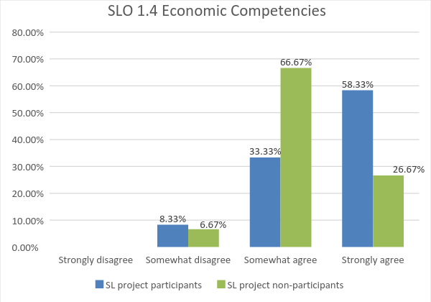

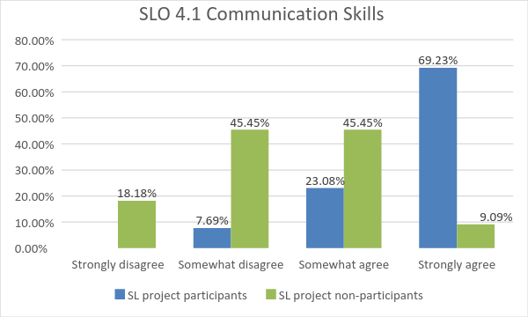

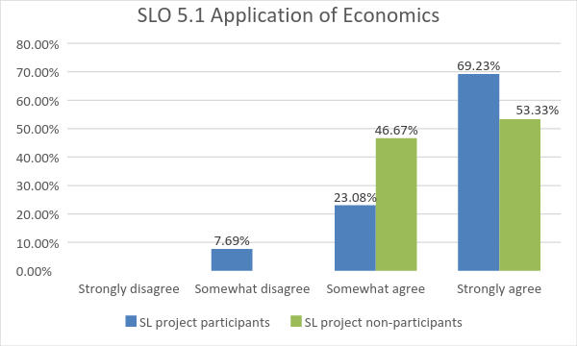

Senior survey
Responses to survey questions Q#4 (SLOs 1.4) and Q#15 (SLO 5.1) were collected from the data. According to the responses in Spring 2016, the table below shows number of respondent who rated the applicable scale:
 | Strongly disagree | Disagree | Neither agree nor disagree | Agree | Strongly agree
SLO 1.4 | 0 | 0 | 1 | 0 | 2
SLO 5.1 | 0 | 0 | 1 | 1 | 1
Note: numbers in the table represent number of respondents rated for each scale.
The information shown in the table can be visualized in the bar chart below. Approximately 67% of students strongly agreed that they have gained good knowledge of Economics in the Department of Economics, which is in line with SLOs 1.4 and 1.5. A majority of the respondents agreed or strongly agreed that they were taught skills that prepare them for a career in economics, which is related to SLO 5.1 in a broader perspective.

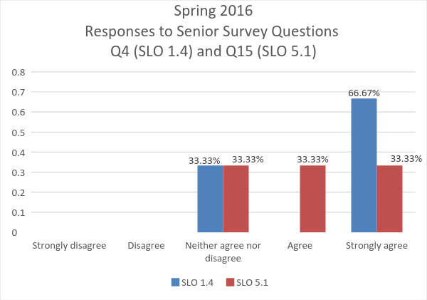

The following table shows Spring 2017’s data regarding the two specific questions:

 | Strongly disagree | Disagree | Neither agree nor disagree | Agree | Strongly agree
Q#4: I have gained good knowledge
of Economics in the Economics
Department
SLO 1.4 | 0 | 0 | 1 | 7 | 8
Q#15: As far as I can tell at present, I
was taught skills that prepare
me for a career in economics.
SLO 5.1 | 0 | 0 | 3 | 8 | 5
Note: number of response is reported in the table.

As visualized in the graph below, more than 90% of the student respondents either agreed or strongly agreed that they gained good knowledge of Economics in the Economics department (SLOs 1.4). Similarly, most respondents (81%) either agreed or strongly agreed that they were taught skills that prepared them for a career in economics (SLO 5.1).
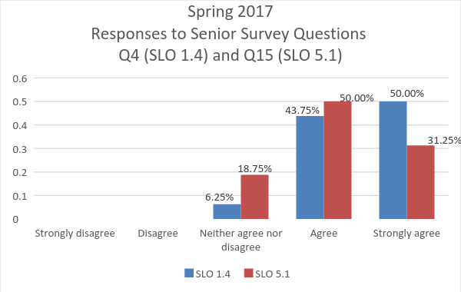
Apparently, the bigger data sample in Spring 2017 than the one in Spring 2016 reduces sample bias and improves assessment outcomes. We see that a larger percent of respondents (graduating seniors and recent graduates) this year agreed or strongly agreed that these two specific SLOs (SLO 1.4 and SLO 5.1) were met during their studies in the Department of Economics.

Writing assignments (ECON 146 Economics of Crime)
A majority of students (88%) achieved a rating of “average” or higher and exhibited satisfactory performance on the designated SLOs in ECON 146. Among these five rating scales, we observe some variation in students’ performance. One reason may be that students from a wide array of programs and departments received different economics trainings and had different educational background prior to taking this class.
The results shown in the table can be visualized in the figure below:
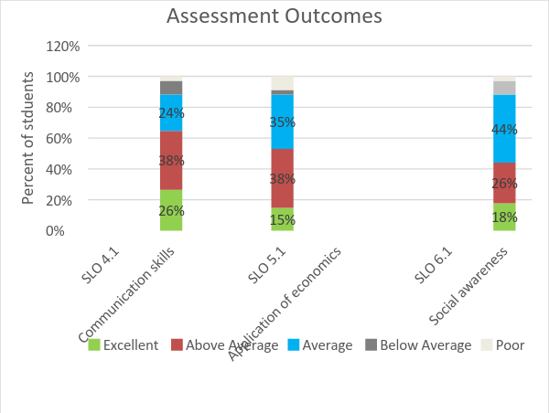

While the largest percent of students achieved the rating of “average” for SLO 6.1, students’ performances regarding achieving SLOs 4.1 and 5.1 are more than satisfactory as reflected by the highest share of students achieving the rating of “above average”.

What changes did/will you make as a result of the findings?
For course embedded assessment, the information provided by the application of this process to a single course (ECON 115T) is somewhat limited, but repeating this process regularly and across different courses could yield useful insights on trends in student learning. In addition to providing a mechanism for collecting consistent information over time for particular courses, this approach also has the advantage of reinforcing the importance of the SOAP’s SLOs for faculty whose courses are part of the assessment plan. For writing assignments, the checklist (or rubric) designed for a single course (ECON 146) could be shared with Department faculty. Writing assignment checklist (or rubric) that specifies SLOs adapted from the Department of Economics SOAP could be used by faculty whose courses are part of the assessment plan in the future. Findings from senior survey suggest that as a result of students’ experiences in the program, an increasing number of students state that they receive relevant knowledge and skills that prepare them for a career in economics. Continuing the senior survey every Spring by adapting some of the SOAP SLOs in the survey questions could guide the continuous improvement of the assessment process and outcome. It was the first semester in Fall 2016 that the SL project was introduced in ECON 119 as an option. The information provided from a small sample analysis could be somewhat biased. By repeating this survey or complementing with other assessment instrument (e.g. site supervisor’s evaluations) could provide valuable insight.

What assessment activities will you be conducting in the 2017-2018 academic year?
The Department has not made a final decision yet regarding assessment activities, but possibilities include:

Assessment activities | Assessment methods  /instruments | Time Frame | Assessment goals
 |  |  | Economic competence | Critical thinking | Communication skills | Application of economics
 |  |  | (Goal #1) | (Goal #3) | (Goal #4) | (Goal #5)
ECON 50 (Tablet vs. traditional)  and ECON 40 (Tablet vs. traditional) | Pre- and Post- tests/survey | Fall 17  Spring 18 | x
ECON 117 | Writing assignments | Spring18 |  | X | x | x
Alumni/Senior Survey | Alumni/senior survey | Spring18 | x |  |  | x

What progress have you made on items from your last program review action plan?

- SOAP Reformatting—In October 2016, the Department SOAP was reformatted to comply with the University’s template. This was achieved with assistance and input from the University Assessment Coordinator and the Department Assessment Coordinator. The underlying mission, goals, and SLOs remain the same but the format and presentation of SOAP have been changed. Feedback and comments on the current SOAP and revisions were discussed and approved by Department faculty.
- Syllabi Review—To support the Craig School Committee on Undergraduate Program (CUP)’s efforts on reviewing Pre-Business core courses, the Department conducted a review of course syllabi for all sections of ECON 40 (Principles of Microeconomics) and ECON 50 (Principles of Macroeconomics) offered in Fall 2016 to provide feedback and guidelines to achieve syllabi consistency across sections.
- Community Engagement—Direct engagement with community organizations has been incorporated in one of the upper-division elective courses through SL activities. The SL project survey is used as an instrument to assess specific SOAP SLOs. Results show improvement in achieving specific SLOs through participating SL projects, relative to traditional class projects.
- Graduating Senior and Recent Graduates’ Feedback—To better assess the experiences and needs of Economics majors, the Department developed a “Senior Survey” asking students to respond to various questions regarding their experiences in Economics courses and their satisfaction with the program.

APPENDIX A: Student Learning Outcomes Assessment
ECON 115T Political Economy of Employment in the U.S.
Fall 2016
Course Assignment ___________________________ Student Number________________

Economic Competence
 | Excellent | Good | Competent | Fair | Poor
Students will interpret assumptions behind the neoclassical and institutional perspectives in labor economics.
Students will apply the formal language and concepts of labor economics to the issue of labor market fissuring.

Critical Thinking
 | Excellent | Good | Competent | Fair | Poor
Students will evaluate neoclassical and institutional perspectives and models to identify key facts, points of consensus and divergence on the history, operation and consequences of fissured workplaces.

Communication Skills

 | Excellent | Good | Competent | Fair | Poor
Students will demonstrate proficiency in writing knowledgeably, coherently, and pervasively on differing perspectives in labor economics and on the issue/problem of labor market fissuring.

APPENDIX B: SERVICE-LEARNING PROJECT SURVEY
ECON 119 Urban & Regional Economics
Fall 2016
Which assignment have you selected?

Individual research project
Service-learning project

Please rate your response to each question by marking the appropriate box.

Questions about the Experience
As a result of participating in this experience: | Strongly Disagree | Somewhat  Disagree | Somewhat Agree | Strongly  Agree
1 I increased my understanding of how to apply concepts and theories learned in class to identify the community agency’s contribution to regional economic development.
(SLO 1.5)
2 I increased my understanding in utilizing economic models and tools to analyze the practical project at the learning site.
(SLO 5.1)
3. I gained experience in using professional and scholarly resources, qualitative or quantitative analysis to help the community agency with their missions.
4. I gained experience in how to communicate effectively with the community agency or target population for service
(SLO 4.1)
5. I gained knowledge in how to describe policy decisions/processes used to address the issues identified in the project.
6. I find myself being able to diffuse economic knowledge in the community through any of the following: collecting and analyzing data, or interacting with target population for service, or participating in practical project.
7 I increased my understanding of how my college education can benefit both me and my community.
8 I am now more likely to involve myself in community service in the future.
9 I now see myself as having the capacity to become a community leader.
10. I now see myself as having the capacity to create positive community change.

APPENDIX C: Senior Survey Selected Questions (Spring 16; Spring 17)

Please indicate your level of agreement with the following statements.

 | Strongly Disagree | Disagree | Neither Agree nor  Disagree | Agree | Strongly Agree
Q#4: I have gained good knowledge
of Economics in the Economics
department
(SLOs 1.4)
Q#15: As far as I can tell at present, I
was taught skills that prepare
me for a career in economics.
(SLO 5.1)

APPENDIX D: Student Learning Outcomes
Writing Assignment Checklist
ECON 146 Economics of Crime
Fall 2016
Student Number________________

Communication Skills

 | Excellent | Above Average | Average | Below Average | Poor
Students will demonstrate proficiency in writing knowledgably, coherently, and pervasively on crime related topics using economic analysis.

Application of Economics

 | Excellent | Above Average | Average | Below Average | Poor
Students will practice independent economic research, including—but not limited to— use of quantitative/empirical analyses (e.g. graphs, tables, and figures).

Social Awareness and Responsibility

 | Excellent | Above Average | Average | Below Average | Poor
Students will identify the economic causes and consequences of crime and describe the policy decisions/processes used to address crime related issues.

