Annual Assessment Report for 2018-2019 AY
Reports completed on assessment activities carried out during the 2018-2019 AY will be due September 30th 2019 and must be e-mailed to the Director of Assessment, Dr. Melissa Jordine (mjordine@mail.fresnostate.edu).
Provide detailed responses for each of the following questions within this word document. Please do NOT insert an index or add formatting. Furthermore, only report on two or three student learning outcomes even if your external accreditor requires you to evaluate four or more outcomes each year. Also be sure to explain or omit specialized or discipline-specific terms.
Department/Program: __Linguistics_________________________ Degree _MA____ Assessment Coordinator: __Dr. Jidong Chen___________________________________
1. Please list the learning outcomes you assessed this year.
SLO goal 4: Ability to carry out curriculum preparation in TESL (Teaching English as a Second Language).
2. What assignment or survey did you use to assess the outcomes and what method (criteria or rubric) did you use to evaluate the assignment? Please describe the assignment and the criteria or rubric used to evaluate the assignment in detail and, if possible, include copies of the assignment and criteria/rubric at the end of this report.
Ling 241 (Graduate Seminar in Teaching English as a Second Language), Fall 2018
We used a major assignment in Ling 241, Teaching Demonstration, to assess the learning outcome 4.
Teaching Demonstration: Each student is assessed on the implementation of a lesson plan that incorporates a drama activity designed to address one of the needs identified in the Needs Assessment. Students is also evaluated on their classroom presence, time management, and the ability to deal with any challenging student behaviors. Students can choose which day they would like to be assessed, but they must make sure their lesson addresses the theme of that week. Students lead one larger scale activity at their internship site, which is graded by their mentor. This is a real-life teaching demo, so they are being graded on their actual teaching in a real situation rather than in class.
The grading rubric is attached as an Appendix at the end of this report.
1
3. What did you learn from your analysis of the data? Please include sample size (how many students were evaluated) and indicate how many students (number or percentage instead of a median or mean) were designated as proficient.
There were 4 students in this class. Some students were nervous and a little underprepared on the day which is reflected in the lower scores, whereas other students thrived and worked really well with the ESL students.
Scores (out of 25):
Student 1: 18 (72%)
Student 2: 25 (100%)
Student 3: 19 (76%)
Student 4: 22 (88%)
Despite the small number of students, all the students were deemed proficient (>70% in score) in executing their first real-life classroom ESL teaching. Students 2 and 4 were excellent overall in delivering the lesson plan.
4. What changes, if any, do you recommend based on the assessment data?
We found that teaching demonstration was a perfect assignment for Ling 241 to assess students’ ability to carry out curriculum preparation in TESL. The detailed grading rubric was very effective in helping students prepare and implement their lesson plan in real-life teaching situations. It ensured that students understood the learning expectations and pay attention to important aspects of language teaching, i.e. organizational structure and time management, quality of in-class task, classroom management, and various presentation skills.
Improvement could be made in devoting a bit more attention and time to TESOL theory and second language acquisition in relation to hand-on practical foreign language teaching techniques.
5. If you recommended any changes in your response to Question 4 in last year’s assessment report, what progress have you made in implementing these changes? If you did not recommend making any changes in last year’s report please write N/A as your answer to this question.
N/A
6. What assessment activities will you be conducting during the next academic year?
We plan to assess the following student learning outcome in 2020-2021 and Ling 248 Sociolinguistics will be assessed for this SLO.
2
SLO Goal 2: Effective skills in the analysis of linguistic data.
Objective 2.1 Identify related elements in a data set.
Objective 2.2 Formulate organizing principles that encompass a data set. Objective 2.3 Recognize and evaluate alternative analyses of a data set.
7. What progress have you made on items from your last program review action plan?
The most recent program review (2015) made the following recommendations in curriculum development for the MA program and the department has made efforts to address each of them.
(1) “The development of new graduate courses in research methods, language structures for teachers, a survey of applied linguistics, a morphology course, and a semantics course in the future.”
• Dr. John Boyle has developed and offered an undergraduate Morphology course last year and this course was offered again in Spring 2018.
• The department conducted a search for a linguist specializing in TESL and applied linguistics in 2016-2017. We successfully hired Dr. Jaydene Elvin who started here in fall 2017. Dr. Elvin has contributed to the development of a graduate course in research methods and will be offering the graduate research methods class in Fall 2018. She is also overseeing two internship opportunities for TESOL students in the MA and BA programs.
• The department also hired John Lyon, a tenure-track faculty member who specializes in semantics. He is teaching a new Semantics undergraduate course in Fall 2018, and will offer a graduate Seminar in Semantics in Spring 2019.
(2) “making the TESOL option more general and applying it to teaching subsequent languages other than English”
• Our core and required courses for the TESOL option are offering students theoretical and practical training to teach subsequent languages other than English. We just submitted a curriculum change proposal to change the TESL option to TESOL/SLAT (Second Language Acquisition and Teaching) to reflect the broader scope of curriculum.
(3) “Culminating Experiences and Student Direction”
• The department faculty have agreed to develop the Project option for the students in the TESOL option. We have included internship opportunities in the TESOL program through Fresno Adult School, San Joaquin Memorial High School, and Agriland Farming Company, and incorporated these experiences into the curricula
for Ling 141, Ling 171, Ling 241 and Ling 244. Ling 241 is being developed as a service-learning course. We will work on developing ways in which these experiences can be incorporated into the students’ culminating experience.
3
Appendix: Ling 241 Grading Rubric for Teaching demonstration
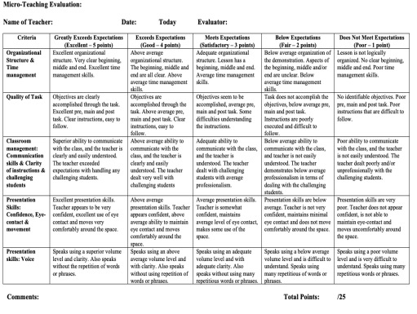4

