Annual Assessment Report for 2021-2022 AY
Reports completed on assessment activities carried out during the 2021-2022 AY will be due September 30th 2022 and must be e-mailed to the Director of Assessment, Dr. Douglas Fraleigh (douglasf@csufresno.edu).
Provide detailed responses for each of the following questions within this word document. Please do NOT insert an index or add formatting. For purposes of this report, you should only report on two or three student learning outcomes (department’s choice) even if your external accreditor requires you to evaluate four or more outcomes each year. Also be sure to explain or omit specialized or discipline-specific terms.

Department/Program: Dept. of Art, Design, and Art History Degree: BFA, Graphic Design

Assessment Coordinator: Virginia Patterson, Assistant Professor
*Please note that we are in the process of updating our SOAP to resolve inconsistencies in acronyms and terminology, numbering systems, and formatting. For clarity within this report, I am using terminology from the latest Graphic Design SOAP. GDO is synonymous with SLO, which will be adopted in our updated SOAP. Additionally, “Outcomes to be measured” listed in our current Assessment timeline are inconsistent with our learning outcomes. This will also be updated in the revised SOAP.
- Please list the learning outcomes you assessed this year.
GDO1.1 Produce graphic design works that identify, define and apply traditional and contemporary principles of art and graphic design.
GDO2.3 Identify, evaluate and apply creative processes for designing graphic design.
GDO4.1 Identify, define and apply technological methods and processes in graphic design including typography, illustration and interactive multimedia design.

- What assignment or survey did you use to assess the outcomes and what method (criteria or rubric) did you use to evaluate the assignment? Please describe the assignment and the criteria or rubric used to evaluate the assignment in detail and, if possible, include copies of the assignment and criteria/rubric at the end of this report.
The graphic design faculty met in Spring 2022 to evaluate both the BFA entrance portfolios (formative assessment) and the BFA exit portfolios, the culminating exhibition portfolio of the Graphic Design BFA (summative assessment). The faculty utilizes the same rubric (administered via a Google Form) to assess both the entry and exit portfolios in order to evaluate growth and development over a two year period, aligning with the program student learning outcomes (GDOs). This rubric employs a 4-point Likert scale, with 4 indicating high proficiency. The rubric is designed to assess all graphic design learning outcomes, however, we will report on the three learning outcomes listed above. In the rubric attached on the final pages of this report, please find an indication of which criteria of the rubric apply to specific learning outcomes.
- What did you learn from your analysis of the data? Please include sample size (how many students were evaluated) and indicate how many students (number or percentage instead of a median or mean) were designated as proficient. Also indicate your benchmark (e.g. 80% of students will be designated as proficient or higher) and indicate the number of students who met that benchmark.
15 student portfolios were evaluated at the formative and the summative levels. The graphic design benchmark for proficiency follows:
Summative Assessment Benchmark (exit portfolio):
85% of students should receive an average score of 3.5 or higher on the graphic design assessment rubric [scale = 1 (low) – 4 (high)]
Formative Assessment Benchmark (entrance portfolio):
85% of students should receive an average score of 2.5 or higher on the graphic design assessment rubric [scale = 1 (low) – 4 (high)]
Because the same rubric is used for entrance and exit portfolios, the formative benchmark is lower, as students are not expected to have mastered all learning outcomes at this level.

When filtering data for the learning outcomes reported this year, the data reveals:
Summative Assessment (n=15)
100% of students received an average score of 3.5 or higher.
Formative Assessment (n=15)
80% of students received an average score of 2.5 or higher.

When viewing all learning outcome data collected, the data reveals the same:
Summative Assessment (n=15)
100% of students received an average score of 3.5 or higher.
Formative Assessment (n=15)
80% of students received an average score of 2.5 or higher.

When analyzing the data for individual learning outcomes reported this year, the data reveals the following:
GDO1.1 Produce graphic design works that identify, define and apply traditional and contemporary principles of art and graphic design.:
Summative Assessment (n=15)
100% of students received an average score of 3.5 or higher.
Formative Assessment (n=15)
80% of students received an average score of 2.5 or higher.

GDO2.3 Identify, evaluate and apply creative processes for designing graphic design.:
Summative Assessment (n=15)
86% of students received an average score of 3.5 or higher.
Formative Assessment (n=15)
86% of students received an average score of 2.5 or higher.

GDO4.1 Identify, define and apply technological methods and processes in graphic design including typography, illustration and interactive multimedia design.
Summative Assessment (n=15)
100% of students received an average score of 3.5 or higher.
Formative Assessment (n=15)
73% of students received an average score of 2.5 or higher.
From this data, we learned that, overall, students are progressing in their proficiency in the learning outcomes assessed when comparing the entry portfolio to the exit portfolio. The formative assessment reveals that students are underperforming with relation to GDO4.1, however, the summative assessment shows that students are developing and excelling in the area of technological methods and processes before graduation. Overall, the formative assessment results are lower than the set benchmark, however, this could be a result of a small sample, or an overly optimistic benchmark. The graphic design faculty are pleased to see that proficiency increases as students progress through the program.
- What changes, if any, do you recommend based on the assessment data?
The graphic design faculty plan to redesign two lower-division courses (formative level) over the next year in order to address deficiencies in the learning outcomes GDO1.1 and GDO4.1. These course-level changes may improve results for the formative assessment.
- If you recommended any changes in your response to Question 4 in your 2020-21 assessment report, what progress have you made in implementing these changes? If you did not recommend making any changes in last year’s report please write N/A as your answer to this question.
The graphic design faculty have continued to develop new projects and courses that support student learning. In the last assessment, students scored lower in the GDO3.1 (Identify, articulate and apply social, cultural, and historical context to graphic design.). The graphic design faculty have redesigned the History of Graphic Design course, a course in which students are initially exposed to socio-cultural and historical relations to graphic design. This course is under curricular review and the faculty hope this will be approved, and that this revision will support student proficiency related to GDO3.1.
- What assessment activities will you be conducting during AY 2022-23?
In AY 2022–23, we will assess the below learning outcomes through direct assessment:
GDO1.2 Identify, define and apply traditional and contemporary theories of graphic design.
GDO3.1 Identify, articulate and apply social, cultural, and historical context to graphic design.

NOTE: For the AY 2021-22 Report, due September 30, 2022, there is no Question 7 pertaining to program review. For future Department/Program Annual Assessment Reports, there will be a question about how your Department/Program has planned to incorporate Justice, Equity, Diversity, and Inclusion into your assessment practices. We will discuss JEDI at assessment workshops in fall 2022 and resources will be available in the Department Coordinators Google Drive.

Assessment Instrument:
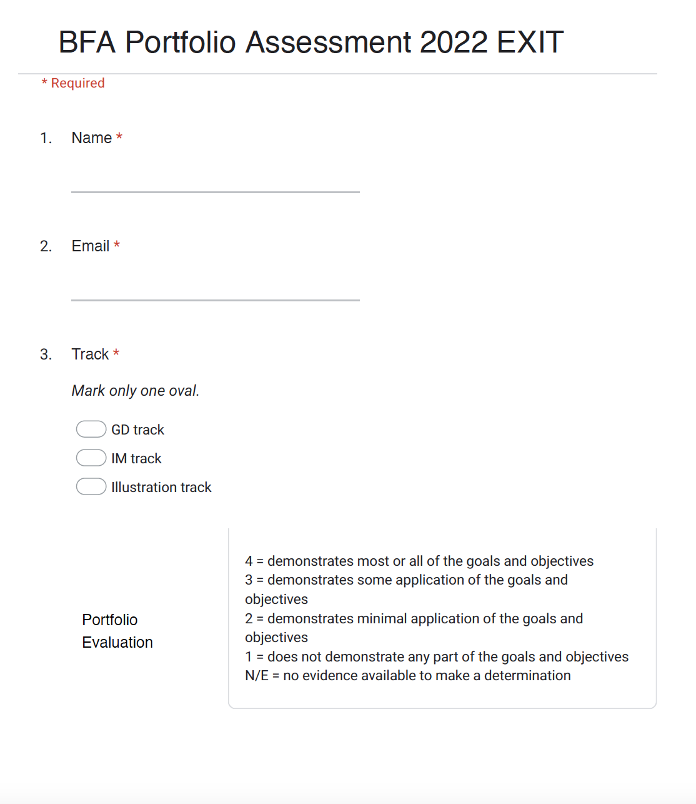
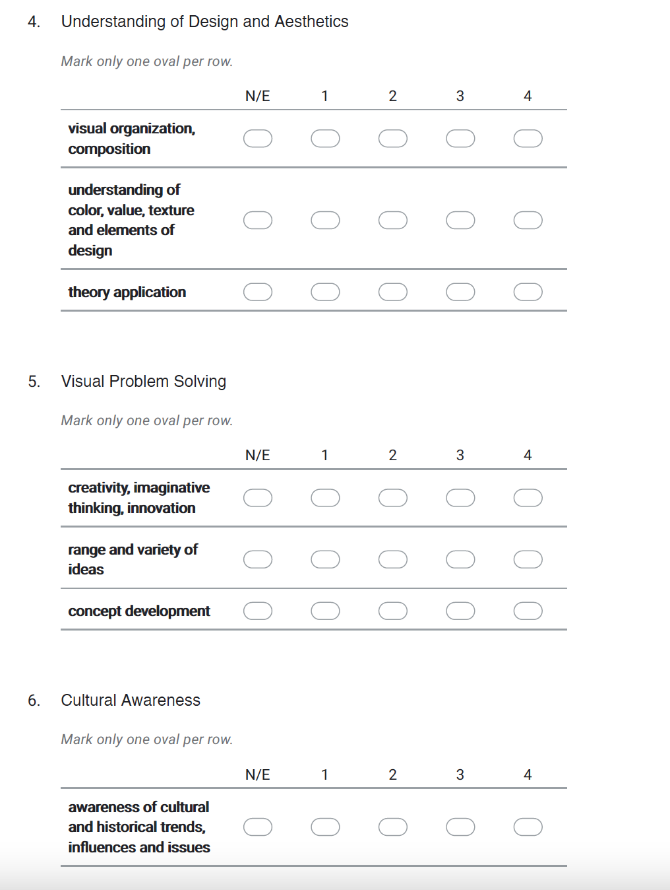

GDO1.1

GDO2.3
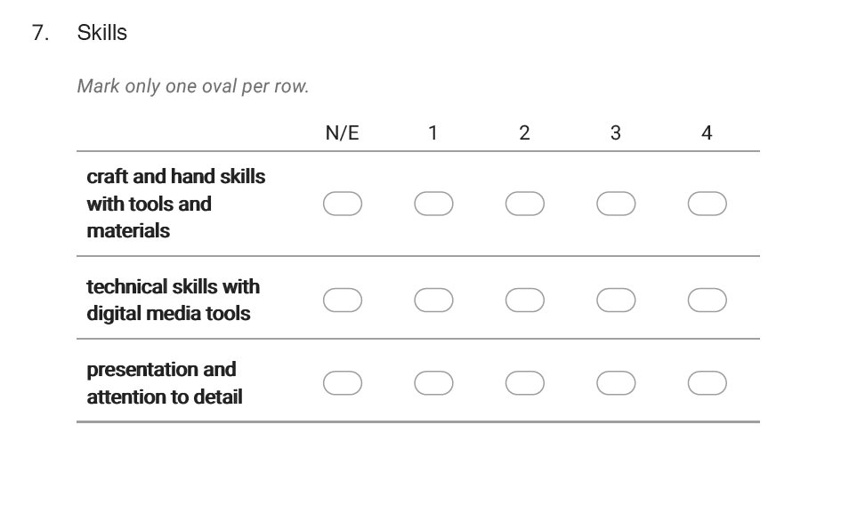
GDO4.1

