Annual Assessment Report for 2021-2022 AY

Department/Program: Integrated Design Degree: BA

Assessment Coordinator: Dr. Laura Huisinga

- Please list the learning outcomes you assessed this year.
GOAL 3: Students will analyze the use of formal elements and design principles.

SLO 3.a. Students will recognize the formal elements (such as space, color, line, and texture) and explain how they are used in individual design outcomes.

- What assignment or survey did you use to assess the outcomes, and what method (criteria or rubric) did you use to evaluate the assignment? Please describe the assignment and the criteria or rubric used to evaluate the assignment in detail and, if possible, include copies of the assignment and criteria/rubric at the end of this report.
Originally last year, we planned to assess a Research Paper from ARTH 124 or ARTH 126, but none of the four majors took those classes. Because of the nature of the Integrated Design Program and the very limited number of students, there is no one class they are attending at the same time. This year we looked at a project from a different studio class for three of the four students and assessed recognizing the formal elements (such as space, color, line, and texture) and explaining how they are used in individual design outcomes. One of the three students did not take any Major classes last year and was not assessed. We used the following criteria with our benchmark being that 80% of our students would score at or above 40pts.
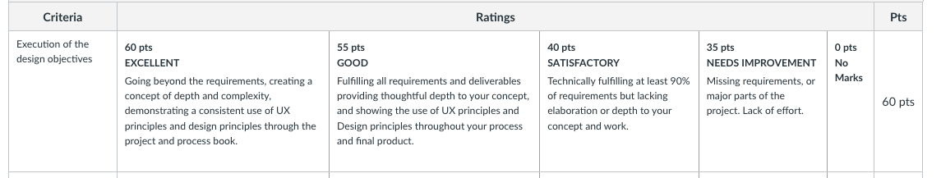
The student evaluation results are as follows.
Student 1: ID 116 : 55pts
Student 2: NA (did not take any Major classes in Fall 21 or Spring 22, only gen eds)
Student 3: GD 37 : 55pts
Student 4: ID 77 : 60pts

- What did you learn from your analysis of the data? Please include the sample size (how many students were evaluated) and indicate how many students (number or percentage instead of a median or mean) were designated as proficient. Also indicate your benchmark (e.g. 80% of students will be designated as proficient or higher) and indicate the number of students who met that benchmark.
Four students were assessed, and they are all making appropriate progress and are designated as proficient for where they are in the program. No students graduated last year so there was no assessment data taken. As a benchmark, 80% of students will be designated as proficient or higher to meet the benchmark. Of the three students assessed, 100% were proficient.

- What changes, if any, do you recommend based on the assessment data?
The road map of the program is currently being revised, so it is a good time to re-evaluate how we will take the initial assessments. The upper division of the integrated BA also needs to be rewritten with a new cumulative class where the exit assessment will be taken.

- If you recommended any changes in your response to Question 4 in your 2020-21 assessment report, what progress have you made in implementing these changes? If you did not recommend making any changes in last year’s report, please write N/A as your answer to this question.
All suggestions are in progress the roadmap and curriculum are currently being revised, as is the viability of the program and recruitment plan.

- What assessment activities will you be conducting during AY 2022-23?
Depending on the updated road map, an initial assessment will be conducted in one or across multiple studio classes of a student design project.
GOAL 2: Students will understand the historical factors (including the cultural, political, economic, and other factors) that shaped the development of architectural, interior, graphics, and experiential design.
SLO 2.b. Students will analyze and critique differences between individual design outcomes as they compare within a historical context.

Since only one student will graduate next year, an indirect reflection assessment will be taken for their exit assessment.

