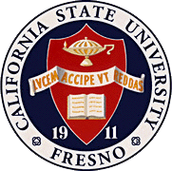
California
State
University,
Fresno
____

James Mullooly (Chair) - COSS
Ahmad Borazan - CSB
Florence Cassel Sharma - JCAST Xuanning Fu - Ex-Officio
Hovannes Kulhandjian - LCE
Tiewei Liu - HML
Primavera Martinez - ASI
Kathi Rindahl - CHHS
Oscar Vega - CSM

Academic Policy & Planning Committee

Academic Senate
Henry Madden Library 3206
5200 North Barton Avenue M/S ML34
Fresno, CA 93740-8014

P 559.278.2743
F 559.278.5745

_{M E M O R A N D U M}

February 15, 2018

MEMORANDUM
TO: Thomas Holyoke, Chair
Academic Senate
FROM: James J. Mullooly, Chair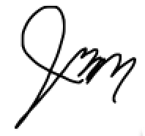
Academic Policy & Planning Committee

RE: APM 415 (Dispute Resolution)

This memorandum will serve to inform the Academic Senate that the Academic Policy & Planning Committee moved to approve your consideration of the following modifications to APM 415 at our 2/8/18 meeting.
MSC: To abolish APM 415 due to its superfluity and invalidity.

A diligent review of possible student concerns and the recommended response (see “Student Concerns Table” and “2011Faculty Handbook Faculty Responsibilities”) found APM 415 to be superfluous. The policy is out of date in that the Dispute Board no longer exists and federal laws have superseded many of the areas the policy addresses. For example, a Title IX dispute about a Protected Category must be covered in a certain way, not by a faculty board.

